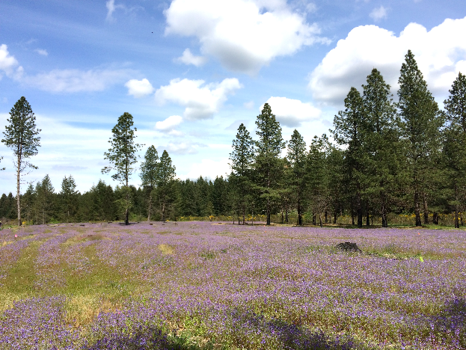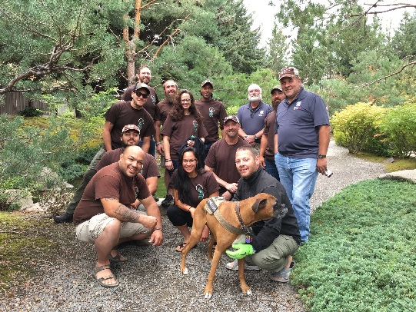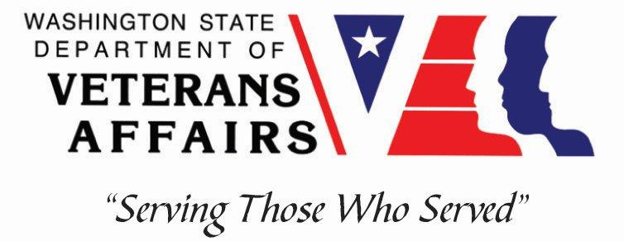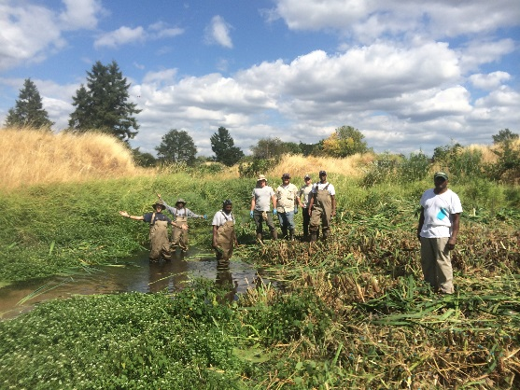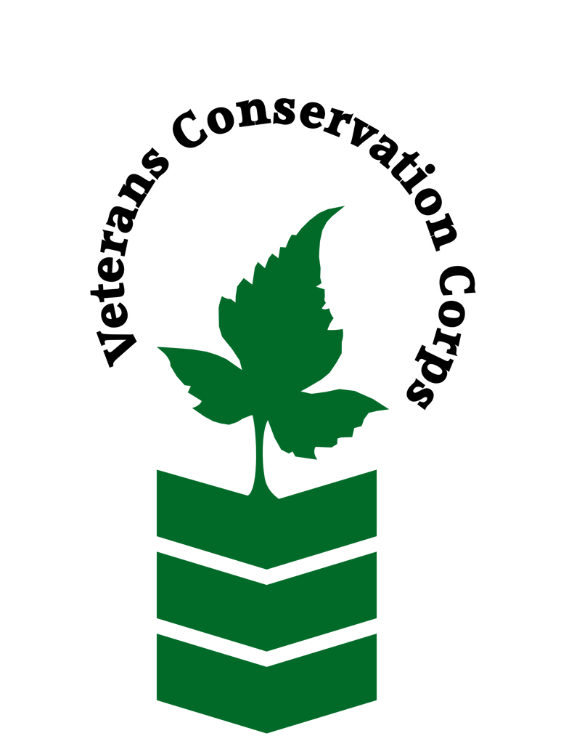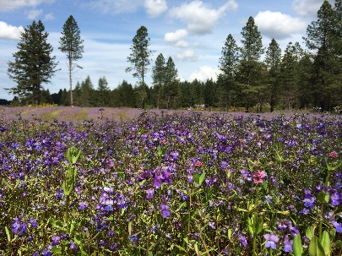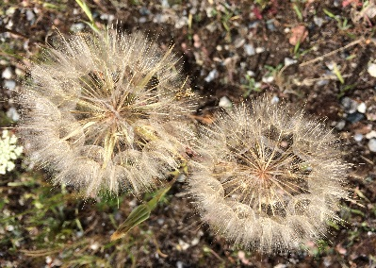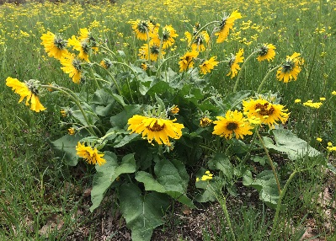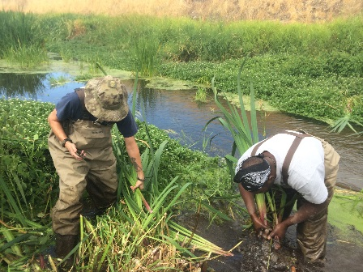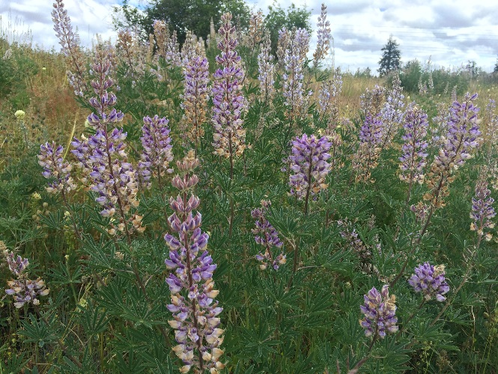

Have you served in the U.S. military and are interested in sustainable agriculture or the conservation and restoration of WA State’s natural resources and habitats?

For more information, contact:

Kim Pham

VCC Program Specialist

kim@dva.wa.gov

(360) 870-0729

www.dva.wa.gov/benefits/internships

Facebook.com/veteransconservationcorps

PO Box 41155

Olympia, WA 98504-1155

## How It All Started

John Beal, a Vietnam veteran, experienced post-traumatic stress disorder upon returning home from combat and found himself battling heart disease in his late twenties. Given a short-term prognosis of only a few months to live, Beal turned to the environment and began work on Hamm Creek, a tributary to the Duwamish River in Seattle, WA. Restoring Hamm Creek transformed into a metaphor for Beal’s life after war. As he worked to clean up his local waterways, he also began to heal his heart, mind and soul.

The VCC is part of the Counseling and Wellness Program of the Washington State Department of Veterans Affairs and was formed by WA State legislation in 2005 largely through the efforts and influence of John Beal.

A Country Worth Defending

Is Worth Preserving

Veterans Conservation Corps Internship

### Opportunities

### Restoration Field Technician

### Trail Stewardship/Maintenance

### NOAA Fisheries Technician

### Farm Intern

### Farmers’ Market Intern

### Storm Water Resource Projects crew

### Garden Builder

### …more to come!

### Some of Our Current Partners

### Center for Natural Lands Management

### National Oceanographic and Atmospheric Administration

### Snohomish Conservation District

### Cascadia Conservation District

### Spokane Conservation District

### Vashon-Maury Island Land Trust

### Growing Veterans Farm

### WA State Parks

* Help protect and restore WA State’s natural resources or engage in sustainable agriculture practices with one of our partner organizations
* Obtain on-the-job training and specific skill sets toward employment in environmental conservation and stewardship or sustainable agriculture
* Participate in professional and personal development workshops
* Connect with your community and other veterans
* Stipend provided to assist with living costs
* Direct access to comprehensive WDVA veteran resources

### The Internship

### **“In Healing Nature, You Heal Yourself.” –John Beal**

**Mission:** Provide veterans with self-directed connections to our state’s natural resources.

**Desired Outcomes:**

* Veterans take the initiative to create a self-directed internship experience
* Given the opportunity to do meaningful work in conserving their natural resources and seeing the results of their efforts, veterans realize their own self-efficacy, resiliency, and ability to overcome their own personal challenges
* Veterans establish and maintain a healthy connection with nature and their community
* Veterans realize a positive shift in their mental, emotional, and physical well-being
* Veterans acquire skills and experiences that may help them in finding meaningful employment