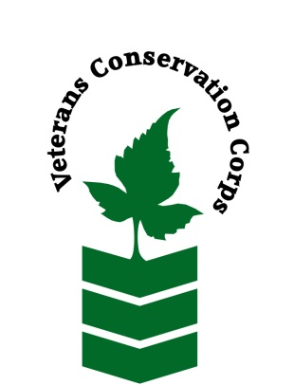
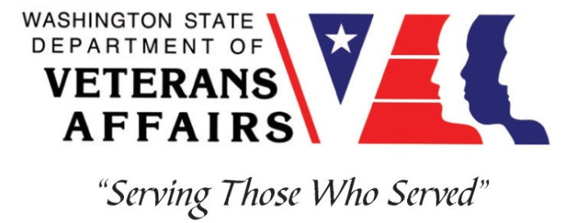
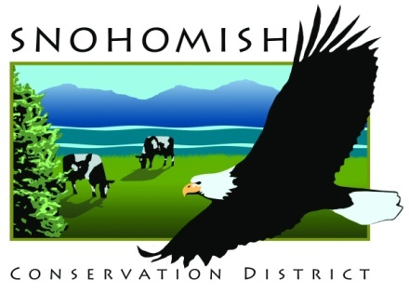
SCD 528 91st Ave NE, Ste A, Lake Stevens, WA 98258-2538
Phone 425-377-7004
www.snohomishcd.org

Veterans Conservation Corps Crew Internship
with the
Snohomish Conservation District

Job Description
This position will work on a 4-person field crew under the supervision of the Snohomish Conservation District’s (SCD) Community Conservation Team. The crew will work with landowners on stormwater resource concerns within urban and residential areas of Snohomish County and Camano Island, and in rural areas doing restoration planting and maintenance. Work will include rain garden construction, rain barrel system construction, planting, brush cutting, and other outdoor work.
- Work week is Monday-Thursday, 7am-5pm
- Pay is in the form of a $2,000 monthly stipend to assist with living expenses
- 4-month terms
  - Term 1: November 1st - February 29th
  - Term 2: March 1st - June 30th
  - Term 3: July 1st - October 31st
  - Currently accepting applications for Term 1. Crew members in good standing at the completion of Term 1 may elect to stay on for Term 2
- All safety equipment (gloves, hard hats, eye protection, ear protection, etc.) is provided

Requirements
- Must be a United States military veteran to be eligible for this position
- Must have dependable transportation to and from the Snohomish Conservation District office
- Must be able to work Monday-Thursday, 7am-5pm

Preferred Knowledge, Skills, and Abilities
This is considered an entry level position and no experience is required. Applicants with the following skills, knowledge, and abilities will be given preference.
- Currently possess or be able to obtain a valid driver’s license
- Experience working on a crew to perform time-sensitive construction projects on private and public property
- Experience implementing safety practices in the field with and without supervision
- Experience operating hand tools and power tools
- Experience operating heavy equipment (mini-excavator, backhoe, etc.)
- Experience in landscape construction
- Able to lift up to 50-lbs
- Able to consistently perform hard labor in all outdoor conditions
- Able to take direction and work as a member of a team
- Able to operate a motor vehicle and haul a trailer
- Motivated and enthusiastic
- Comfortable speaking to landowners and other members of the public about projects

Training
All necessary training required to perform the essential functions/duties is provided on the job.

In addition to on-the-job training, this position may include the following formal trainings and certifications to aid in professional development and job training:
- Low Impact Development/Green Stormwater Infrastructure
- Heavy machinery operation
- VCC orientation
- CPR/First Aid
- Posttraumatic Growth Training
- PTSD/TBI/Mental Health/Suicide Awareness Training
- WDVA Veteran Peer Corps Certification
- Vet Corps Annual Training (every August)
- Vet Corps Mid-year Training (every February)
- Resume/cover letter/job interviews

Apply
All applicants must pass a background check. To apply for this internship, email a copy of your DD214 and driver license, a resume, and a cover letter explaining your interest in this internship to:

Kim Pham
Veterans Conservation Corps Program Specialist
kim@dva.wa.gov

Questions?
To learn more about the Veterans Conservation Corps, contact:

Kim Pham
Veterans Conservation Corps Program Specialist
kim@dva.wa.gov

For more information about the job requirements, contact:

Taylor Pesce
Snohomish Conservation District
tpesce@snohomishcd.org
425.377.7022

