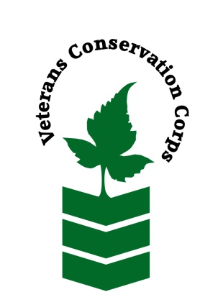
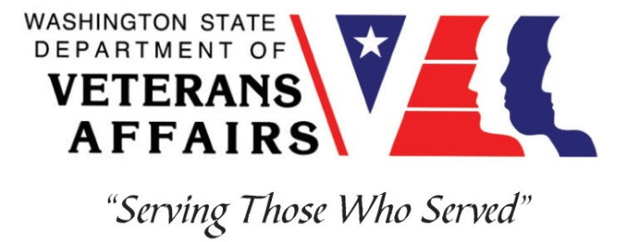
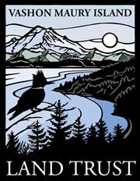
10014 SW Bank Rd, Vashon, WA 98070
(206) 463-2644
www.vashonlandtrust.org

Veterans Conservation Corps
with
Vashon Maury Island Land Trust
Stewardship Internship

General Description:

The Vashon-Maury Island Land Trust seeks an intern to assist with general Stewardship functions. Our work is largely comprised of on-site preserve maintenance (including trail maintenance) and upkeep of our newly conserved farm, but also requires office work from time to time. The VCC intern will work closely with the Stewardship team, volunteer crews, and summer crews, as well as independently to accomplish organizational goals.

The internship will require up to 40 hours per week, will begin May 2020, and includes a stipend of $1800/month to help cover living expenses.

Schedule:

We work Monday through Thursday from 7 to 5, with occasional weekend and evening work not to exceed 40 hours per week. Alternative hours and flexible scheduling to meet the intern’s needs will be discussed on a case-by-case basis.

Essential Functions:

Preserve Stewardship
- Accomplish a variety of stewardship actions including but not limited to invasive weed removal, restoration project maintenance, restoration tree planting, and tool maintenance.
- Remove structures, fencing, and miscellaneous debris, from properties to prep sites for restoration plantings and new trail construction.
- Build split rail fencing around new trailhead parking locations and install trailhead and preserve signs.
- Conduct regular trail maintenance and assist with trail construction, including but not limited to weed whacking, turnpike and bridge building, and brush clearing.

- Participate in volunteer work parties on farm or preserves
- Represent Vashon Land Trust to preserve visitors and neighbors
- Help design of a new restoration planting project, choosing plant species and quantities, and help with organizing volunteer and staff labor.

Farm Production
- Care for annual vegetable crops from seeding in greenhouse through transplanting, cultivation, and harvest in the field.
- Set up, maintain, and operate irrigation system.
- Participate in various building projects, possibly including trellising and high tunnel, small shed, and other shelter construction.
- Carry out site maintenance such as mowing and weed whacking.

Other Duties:
- Participate in community outreach events and funding events as needed
- Other conservation program and administrative duties assigned by supervisor
- Other duties as assigned by supervisor

Training
All necessary training required to perform the essential functions/duties is provided on the job.

In addition to on-the-job training, this position may include the following formal trainings and certifications to aid in professional development and job training:

- VCC orientation
- CPR/First Aid
- Posttraumatic Growth Training
- PTSD/TBI/Mental Health/Suicide Awareness Training
- WDVA Veteran Peer Corps Certification
- Vet Corps Annual Training (every August)
- Resume/cover letter/job interviews
- Wilderness First Aid Training
- Native Plant Identification
- Restoration Design

Qualifications:
- This position requires the applicant to be a United States military veteran
- Valid Driver’s license
- Experience with Microsoft Word
- Ability to work independently in the field while demonstrating a strong work ethic and safety common sense
- Ability to work as part of a team of staff and/or community volunteers in the field
- Ability to meet and work with new people
- Ability to act as a leader and uphold high ethical standards
- Excellent communication skills
- Excellent attention to detail
- Willingness to learn new skills
- Preferred: first aid training

Physical Requirements:
- Physically able to conduct demanding field work and traverse occasionally rough terrain in a variety of weather conditions
- Ability to lift up to 50 pounds
- Ability to climb over brush, logs, fences, creeks, and other obstacles on protected properties

Apply

All applicants must pass a background check. To apply to this job, email a copy of your DD214, a copy of a federal or state issued picture ID, a resume, and a cover letter explaining your interest in this internship to:

Kim Pham
Veterans Conservation Corps Program Specialist
kim@dva.wa.gov

Questions?

To learn more about the Veterans Conservation Corps Internship Program, contact:

Kim Pham
Veterans Conservation Corps Program Specialist
kim@dva.wa.gov

For more information about the Vashon Maury Island Land Trust, contact:

Abel Eckhardt
Stewardship Director
Abel@vashonlandtrust.org
(206) 463-2644

