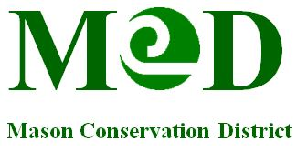
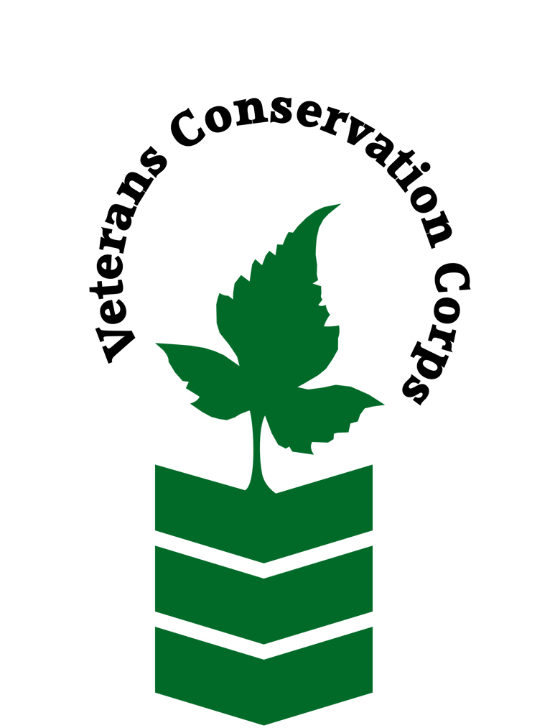
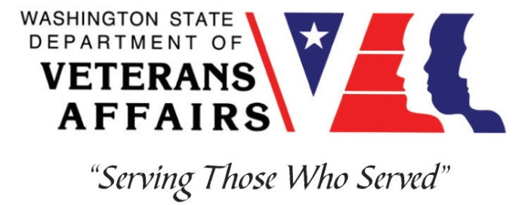

450 W Business Park RD
Shelton, WA 98584
www.masoncd.org
Veterans Conservation Corps Internship Program
with
Mason Conservation District

Field Restoration Crew Internship

Overview

The Mason Conservation District Field Restoration Crew implements and maintains habitat restoration projects. This includes working efficiently and effectively on a team to implement restoration activities including planting, maintenance of planting sites using power tools, and treatment of invasive plants with the use of herbicides. To provide these services, the District maintains a team that includes the Crew Lead, Assistant Crew Lead, and several crew members.

The selected applicant will be placed on the District’s 5-7 person Field Restoration Crew under the supervision of the Field Crew Lead. The internship will provide meaningful training and field experience related to habitat restoration.

Schedule and Compensation

The internship will require up to 40 hours per week and will last for a minimum of 4 months with a potential opportunity to extend the internship duration. Applications will be accepted year-round. The internship includes a stipend of $1800/month to help cover living expenses.

A typical work week will be Monday through Thursday from 7 to 5:30, not to exceed 40 hours per week. Work days and times may change to Monday through Friday 8 to 4:30 to accommodate project needs and/or seasons. Alternative hours and flexible scheduling to meet the intern’s needs will be discussed on a case-by-case basis.

Essential Functions:
- Maintain Planting Sites:
  - Intern will work with crew to maintain existing planting sites in the fall and spring. This is done by safely utilizing tools such as brushcutters and machetes.
- Plant Native Trees and Shrubs:
  - Intern will work with crew to plant both bare root and potted stock plants in uneven terrain utilizing shovels at planting sites in the winter.
- Invasive Weed Control:
  - Intern will work with crew to safely control invasive weeds by mechanical means (utilizing a brushcutter) in the fall or spring. Control will also include treating various weeds by applying herbicides utilizing a backpack sprayer under the supervision of the Field Crew Lead in the summer.

The Field Restoration Crew works in all weather conditions and in uneven terrain working on sites that are located in forests, wetlands, and riversides.

Other Duties:
On an occasional basis the intern may have the opportunity to:
- Assist other District staff as needed, i.e. land surveying
- Operate non-motorized watercraft used to access select work sites
- Collecting environmental field data
- Build wildlife/livestock exclusion fencing
- Practice proper tool maintenance
- Other duties may be assigned.

Qualifications:
- This position requires the applicant to be a United States military veteran
- Valid Driver’s license
- Ability to safely and effectively work as part of a team
- Ability to meet and work with new people
- Ability uphold high ethical standards and properly represent the District to members of the community
- Excellent attention to detail
- Good communication skills
- Ability to operate hand and power tools and other mechanical equipment safely for extended periods of time
- Willingness to learn new skills
- Preferred: first aid training

Physical Requirements:
- Physically able to conduct demanding field work and traverse occasionally rough terrain in a variety of weather conditions on a daily basis
- Ability to carry 50 pounds over uneven terrain
- Ability to climb over brush, logs, fences, creeks, and other obstacles

Training
All necessary training required to perform the essential functions/duties is provided on the job.

In addition to on-the-job training, this position may include the following formal trainings and certifications to aid in personal & professional development:

- CPR/First Aid
- PTSD/TBI/Mental Health/ Suicide Awareness & Prevention
- WDVA Veteran Peer Corps Certification
- VCC Annual Retreat and Training
- Resume/cover letter/job interviews

Apply

All applicants must pass a background check.

To apply, email a resume, a copy of your DD214, a copy of your current driver’s license, and a cover letter explaining your interest in this internship to:

Kim Pham
Veterans Conservation Corps Program Specialist
kim@dva.wa.gov

Questions?
To learn more about the Veterans Conservation Corps, contact:

Kim Pham
Veterans Conservation Corps Program Specialist
kim@dva.wa.gov

For more information about Mason Conservation District:

Evan Bauder
Habitat Program Manager
evan@masoncd.org

