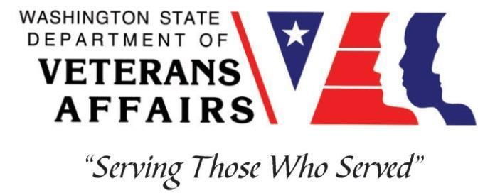
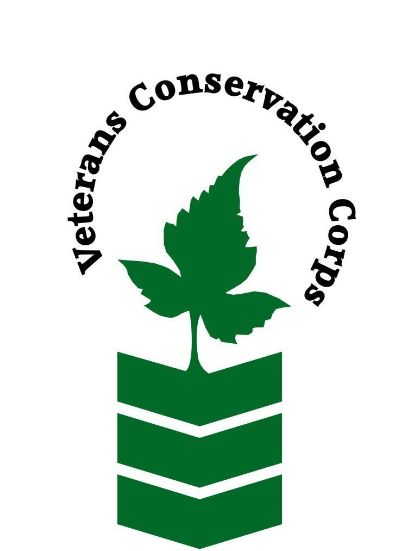

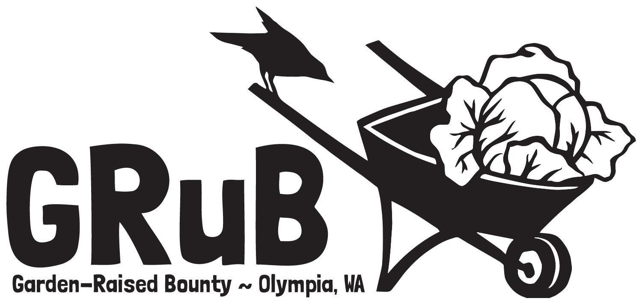

2016 Elliott Ave NW, Olympia, WA 98502
goodgrub.org

Veterans Conservation Corps Internship Program
with
Garden-Raised Bounty
GRuB Garden Project Internship

***This position requires the applicant to be a United States military veteran***

General Description

Lead Builder Intern: The Lead Builder Intern will gain hands-on experience in community building & garden building by supporting the GRuB Garden Project (GGP) team in coordinating and constructing backyard gardens with low-income families in our community. The Lead Builder Intern will assist in leading teams of volunteers and other interns to construct over 30 gardens throughout the Spring Quarter. This position will also help assist the GGP coordinator to facilitate gardener relationships, schedule builds, and help facilitate workshops with the Community Food Solutions manager. The position may also provide regular office & organizational support as needed. You will work closely with the GRuB Garden Project coordinator and other GRuB staff, volunteers and interns.

This 3-month internship will begin April 2021, with the possibility of extension to September 2021, and includes a stipend of $900/month for a part-time internship (up to 20 hours/week) or $1800/month for a full-time internship (up to 40 hours/week) to help cover living expenses.

Schedule:

Flexible schedule. The Intern will work closely with the GGP Coordinator and Community Food Solutions Manager to determine a schedule that meets their needs. A typical work week consists of Monday – Friday, 9 am – 5 pm. There may be occasional early morning, evening and/or weekend work hours that will be pre-scheduled to fit within 20 hours/week (part-time) or 40 hours/week (full-time).

Essential Functions
GRuB Garden Project:
- Support the GRuB Garden Coordinator as needed.
- Develop gardener orientation materials & resources.
- Coordinate garden builds with gardeners & maintain communication with gardeners as needed.
- Drive the GGP truck and lead teams of volunteers and interns on garden builds.
- Safe operation of a full-size truck with dump-bed and various garden construction tools, i.e. wheelbarrows, shovels, hammers, saws.
- Represent GRuB to veterans, volunteers, and general community members.
- Offer a welcoming, knowledgeable and friendly presence to veterans and volunteers.
Other Duties:
- Participate in community outreach events and funding events as needed.
- Other program and administrative duties assigned by the supervisor.
- Ongoing photo and written documentation of program activities.
- Participate in weekly GGP team meetings.
Qualifications:
- This position requires the applicant to be a United States military veteran
- Valid Driver’s license.
- Personal means of transportation to travel to and from garden build sites.
- Preferred: first aid training.
- Preferred: experience with MS Office programs.

Preferred Core Competencies:
- Ability to work independently in the field while demonstrating a strong work ethic and safety common sense.
- Ability to work as part of a team of staff and/or community volunteers in the field.
- Enthusiastic about working with people from diverse backgrounds.
- Curious, open-minded, respectful and committed to developing multicultural communication skills.
- Ability to act as a leader and uphold high ethical standards.
- Excellent communication skills.
- Excellent attention to detail.
- Willingness to learn new skills.

Physical Requirements:
- Physically able to conduct physically demanding work in a variety of weather conditions.
- Ability to lift 20-40 pounds.
- Ability to safely operate a full-size pick-up truck.

Training

All necessary training required to perform the essential functions/duties is provided on the job.

In addition to on-the-job training, this position may include the following formal training and certifications to aid in personal and professional development:

- Veterans Cultural Competency Training
- CPR/First Aid
- Posttraumatic Growth Training
- PTSD/TBI/Mental Health/ Suicide Awareness & Prevention
- WDVA Veteran Peer Corps Certification
- VCC Annual Training (every August)
- Environmental conservation conferences/symposiums/workshops
- Growing your veteran-owned small business
- Whole Farm Planning and Agricultural Entrepreneurship
- Other trainings/certifications as available and desired by intern

Apply

All applicants must pass a background check.

To apply, email a resume, a copy of your DD214, a copy of your current driver’s license, and a cover letter explaining your interest in this internship to:

Kim Pham
Veterans Conservation Corps Program Specialist
kim@dva.wa.gov

Questions?

To learn more about the Veterans Conservation Corps Internship Program, contact:

Kim Pham
Veterans Conservation Corps Program Specialist
kim@dva.wa.gov

For more information about GRuB, contact:

Beau Gromley
Community Food Solutions Manager
Beau@goodgrub.org

Jennah Kemp
GRuB Garden Project Coordinator
Jennah@goodgrub.org

