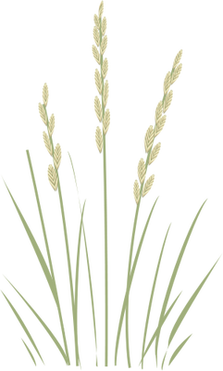
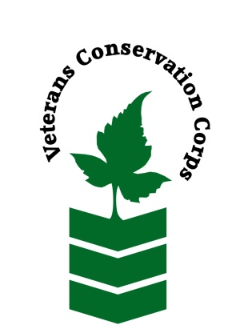
Okanogan
Conservation
District

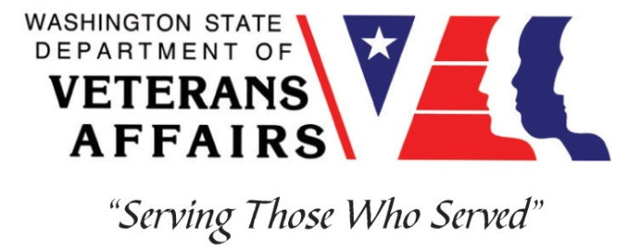

Okanogan CD, 1251 2nd Ave. S., Room 102, Okanogan, WA 98840
Phone 509-422-0855
www.OkanoganCD.org

Veterans Conservation Corps
with
Okanogan Conservation District
Natural Resource Technician Internship

General Description

The Okanogan Conservation District is a dynamic organization comprised of volunteer board members and paid staff members that are leaders in “on the ground conservation”. We work closely with landowners, coworkers, conservation partners, and others to develop and implement voluntary conservation plans specific to each landowner’s needs. We seek individuals that will complement our highly productive, energetic, and skilled staff to deliver quality conservation programs to Okanogan County residents.

Position Summary
This position will work with staff at the Okanogan Conservation District (OCD) to implement natural resources conservation projects and vegetation monitoring efforts during the 2021 field season. Work may include:

- Helping with riparian and wildlife planting projects by clearing and preparing planting areas and then planting and maintaining trees and shrubs
- Building novel livestock exclusion barriers using slash and debris from thinning efforts
- Data collection related to vegetation monitoring efforts
- Natural resource education and community outreach activities
- Other outdoor work related to OCD projects and priorities

All safety equipment (gloves, hard hats, eye protection, ear protection, etc.) is provided.

Schedule and Compensation

- 6-month term (May 1st - October 30th)
- Work week is generally Monday-Friday, 8am-4:30pm
- Includes a stipend of $1,800/month for a full-time internship (~40 hours/week) or $900/month for a part-time internship (~20 hours/week) to assist with living expenses

Qualifications

- This position requires the applicant to be a United States military veteran
- Valid Driver’s license
- Basic Computer Skills; Microsoft Word and Excel
- Ability to work independently, and as part of a team
- Ability to meet and work with new people
- Ability to uphold high ethical standards and properly represent the District to members of the community
- Excellent attention to detail
- Experience implementing safety practices in the field with and without supervision
- Good communication skills
- Willingness to learn new skills

Physical Requirements

- Physically able to conduct demanding field work and traverse occasionally rough terrain in a variety of weather conditions on a daily basis
- Ability to carry 50 pounds over uneven terrain
- Ability to climb over brush, logs, fences, creeks, and other obstacles

Training

All necessary training required to perform the essential functions/duties is provided on the job.

In addition to on-the-job training, this position may include the following formal trainings and certifications to aid in professional development and job training:

- Veterans Cultural Competency Training
- CPR/First Aid
- Posttraumatic Growth Training
- PTSD/TBI/Mental Health/ Suicide Awareness & Prevention
- WDVA Veteran Peer Corps Certification
- VCC Annual Training (every August)
- Environmental conservation conferences/symposiums/workshops
- Growing your veteran-owned small business
- Whole Farm Planning and Agricultural Entrepreneurship
- Other trainings/certifications as available and desired by intern

Apply

All applicants must pass a background check.

To apply for this internship, email a copy of your DD214 and driver license, a resume, and a cover letter explaining your interest in this internship to:

Kim Pham
Veterans Conservation Corps Program Specialist
kim@dva.wa.gov

Questions?
To learn more about the Veterans Conservation Corps, contact:

Kim Pham
Veterans Conservation Corps Program Specialist
kim@dva.wa.gov

For more information about the internship requirements, contact:

Ben Carroll
Okanogan Conservation District
Ben@OkanoganCD.org
509-422-0855 x 111

