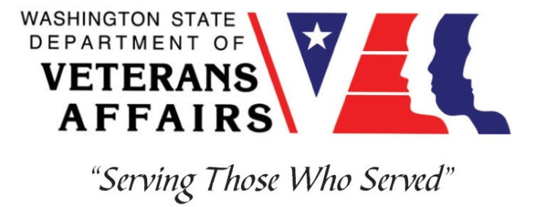
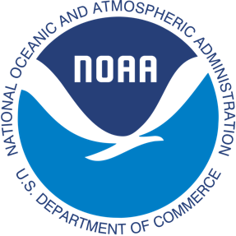
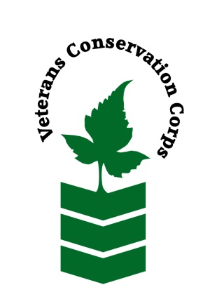
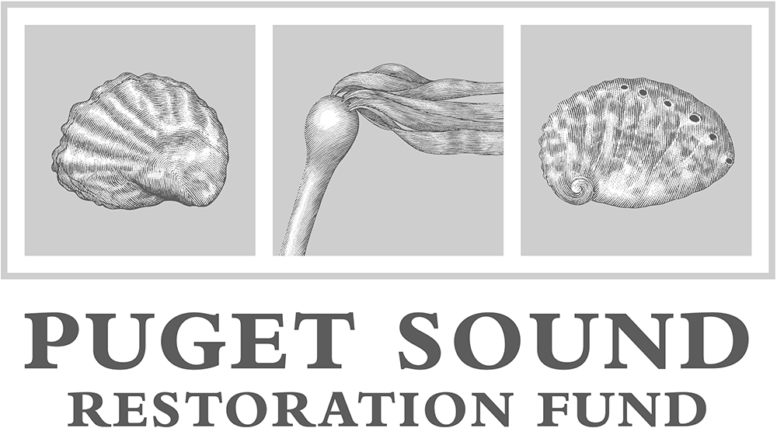

Kenneth K. Chew Center for Shellfish Research and Restoration at
Northwest Fisheries Science Center’s Manchester Research Station
7305 Beach Dr E, Manchester, WA 98353
(206) 780-6947 or (206) 795-6378
https://www.nwfsc.noaa.gov/ and https://restorationfund.org/programs/hatchery/
NOAA WDVA Veterans Conservation Corps Fisheries Internship Program
with the
Puget Sound Restoration Fund

***This position requires the applicant to be a United States military veteran***

Period of Performance: January-June 2022

Program Description
The NOAA WDVA Veterans Conservation Corps Fisheries Internship Program is a Washington-based internship focused on marine science and stewardship of coastal resources. Since 2016, NOAA has been funding these internships and partnering with the WDVA Veterans Conservation Corps to deliver high level science-based experiences at NOAA Research Centers and NOAA partner organizations throughout Washington. This internship adds Puget Sound Restoration Fund (PSRF) to this NOAA and WDVA Veterans Conservation Corps partnership. The internship will be supervised by PSRF and located, COVID-19 restrictions permitting, at the Kenneth K. Chew Center for Shellfish Research and Restoration (Chew Center) that PSRF operates at NOAA’s Manchester Research Station on the Kitsap Peninsula. The position will be supported and coordinated by the VCC and NOAA.

General Description
This position is with Puget Sound Restoration Fund (PSRF), a non-profit organization that works to restore abundant marine resources and our connections to them through a diverse portfolio of in-the-water projects throughout Puget Sound. The main focus of PSRF restoration is living marine habitat and species, using structure forming species (Olympia oysters, bull kelp) and habitat enhancing species (pinto abalone). Another focus for PSRF is maintaining and recovering clean water in shellfish growing areas and developing mitigation strategies for ocean acidification. PSRF is dedicated to measurably improving conditions in Puget Sound through: improved water quality, increased abundance of native species, additional acres of restored habitat, enhanced ecological benefits, and re-forged connections with healthy marine resources. PSRF’s projects occur throughout Puget Sound, with staff concentrated in two central hubs - a main office on Bainbridge Island, and our conservation hatchery (the Chew Center), further described below.
PSRF and NOAA established the Chew Center as a facility dedicated to research and restoration of native marine species including Olympia oysters, bull kelp, pinto abalone, giant red sea cucumbers, and basket cockles. The collaborative research goals of the Chew Center are to:
- Culture genetically-diverse native oysters and abalone to preserve local populations
- Expand the ability to restore native kelp and shellfish habitat in the Pacific Northwest
- Understand impacts of ocean acidification on shellfish and other marine life
- Advance the technology and practices of conservation aquaculture
- Establish a center of excellence for shellfish research & restoration

Position Description
The intern will assist across PSRF’s programs at the Chew Center, including hatchery production of restoration-grade pinto abalone, Olympia oysters, and possibly kelp, microalgae culture, animal husbandry, data collection and management, and facilities maintenance. As part of the PSRF team, the intern will have the opportunity to assist with many projects, and gain a variety of experiences across programs. Depending on when the intern can access the facility, they will be able to:

- Provide support for animal husbandry and kelp propagation
- Provide daily maintenance of pinto abalone and Olympia oyster broodstock, larval, post-set and seed culture systems
- Assist with induced spawns of multiple species
- Keep accurate records of larval, post-set and seed growth, survival, and culture conditions
- Assist with all aspects of microalgae culture including monitoring cultures, sterile transfers and media preparation.
- Assist with bull kelp propagation for use in enhancement trials
- Maintain facilities and operational systems
- Regularly clean/repair/replace all components of water treatment system (filters, pumps, heaters, heat exchangers) and plumbing
- Assist in construction of components of animal, microalgae and macroalgal culture systems

There are also anticipated to be additional opportunities to network and communicate with NOAA research staff and communicate the results and experiences of this internship.
This 6-month internship includes a stipend of $1800/month for a full-time internship (approximately 40 hours/week) to help cover living expenses.

Schedule:
Interns are expected to serve 40 hours over four or five days each week, and can expect occasional weekend and nighttime field work activities. Alternative hours and flexible scheduling to meet the intern’s needs will be discussed on a case-by-case basis.

Required Skills, Knowledge, and Abilities
- This position requires the applicant to be a United States military veteran.

Preferred Qualities
Applicants with the following skills, knowledge, and abilities will be given preference.
- Experience with marine or aquatic organism care or culture, microscopy, general laboratory equipment and procedures
- Ability to work independently and as a member of a team
- Strong self-initiative, and good attention to detail
- Follows appropriate safety practices in the lab and the field
- Motivated and enthusiastic, with an interest in marine ecosystems, environmental restoration and conservation

Physical Requirements:
- Ability to work outdoors in all weather conditions

Training
All necessary training required to perform the essential functions/duties is provided on the job.

In addition to on-the-job training, this position may include the following formal trainings and certifications to aid in professional development and job training:
- CPR/First Aid
- Posttraumatic Growth Training
- PTSD/TBI/Mental Health/ Suicide Awareness & Prevention
- WDVA Veteran Peer Corps Certification
- VCC Annual Training
- Resume/cover letter/job interviews
- Environmental conservation workshops/conferences

Apply
All applicants must pass a background check.

To apply, email a resume, a copy of your DD214, a copy of your current driver’s license, and a cover letter explaining your interest in this internship to:

Kim Pham
Veterans Conservation Corps Program Specialist
kim@dva.wa.gov

Questions?
To learn more about the NOAA WDVA Veterans Conservation Corps Internship Program, contact:

Kim Pham
Veterans Conservation Corps Program Specialist
kim@dva.wa.gov

John Floberg
NOAA
Marine Habitat Resource Specialist
John.r.floberg@noaa.gov

For more information about NOAA and Puget Sound Restoration Fund (PSRF), contact:
Penny Swanson (NOAA), Jodie Toft (PSRF) or Ryan Crim (PSRF)

Penny Swanson Jodie Toft Ryan Crim
penny.swanson@noaa.gov jodie@restorationfund.org ryan@restorationfund.org
206-860-3282 (206) 795-6378 (206) 406-8827

