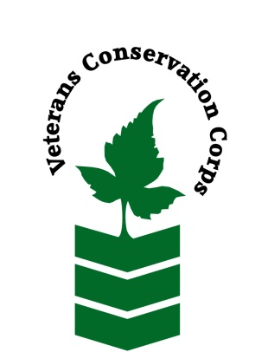
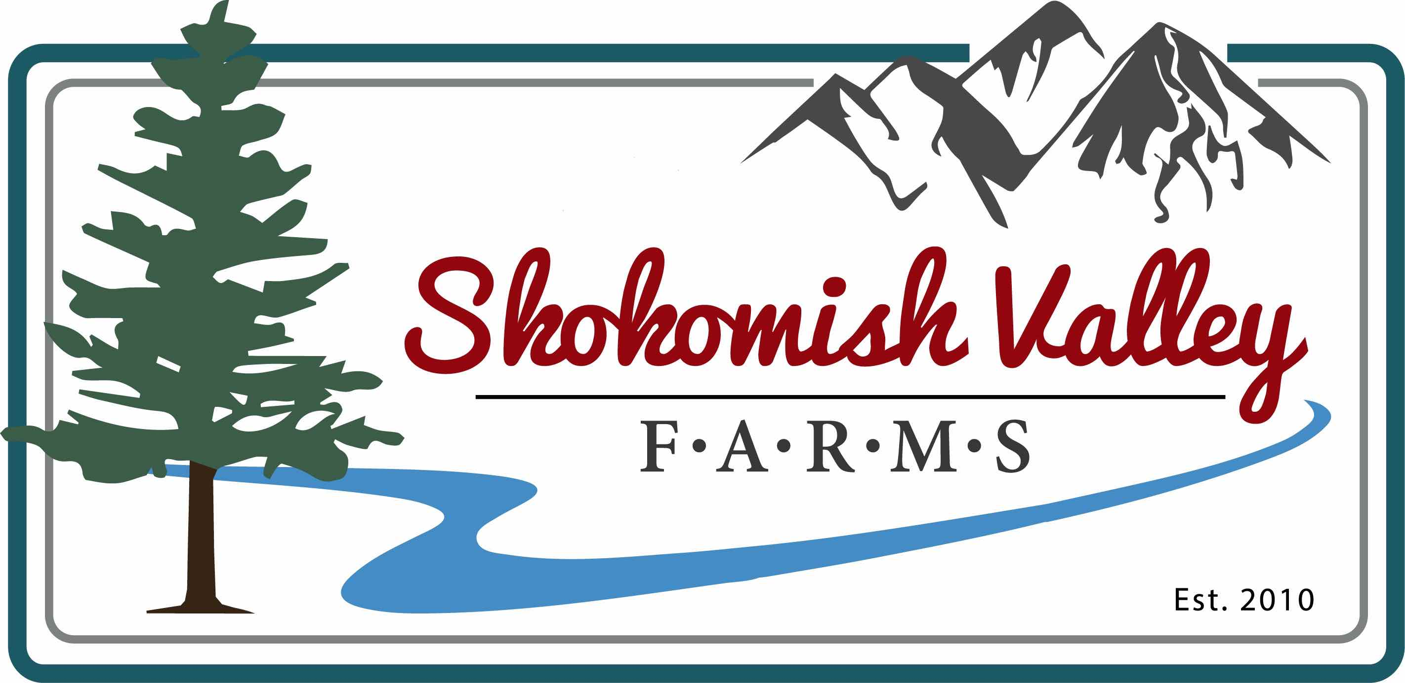

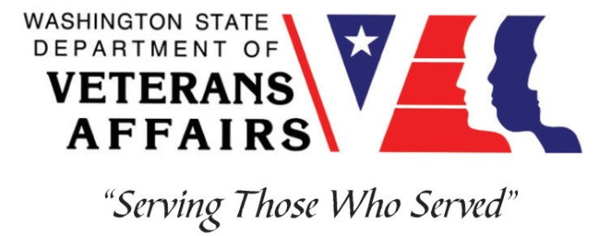

10 N Sweetgrass Ln
Shelton, WA 98584
www.SkokomishValleyFarms.com
(360)545-5970

Veterans Conservation Corps
with
Skokomish Valley Farms
Farm Internship

Overview

Our Story: Growing Good Food. Building Community. Sustaining the Land. We are certified organic and enjoy making the land more productive each year! Our animals are raised with the highest standard of living consistent with their agricultural purpose. We are located at the foot of the Olympic Mountains in Western Washington. Our 720-acre farm is owned by several families, including veterans, who work together to provide tasty vegetables and eggs for the local community. We are passionate about the food we grow and are dedicated to supporting a truly local and sustainable food system. We have begun adding an orchard and sheep flock to our operations, and look forward to expanding in other areas in the future as well. We sell our produce and eggs through CSA, Farmers Markets, and an online Food Hub.

Position Summary

The candidate will be introduced to small-scale farming, livestock management, greenhouse management, community building, all with a focus on regenerative practices. The majority of our effort is currently in growing 3-4 acres of vegetables, followed closely by our 800 chicken egg laying operations, along with the beginnings of our orchard and sheep flock.

Schedule and Compensation

This 6-month internship will begin March 2022, with the possibility of an extension. Includes a monthly stipend to assist with living expenses: $1800 for a full-time internship (approx. 40 hrs/week) and $900 for a part-time internship (approx. 20 hrs/week). Days and hours are flexible with the season and worker availability, but typically Tuesday through Saturday, 8am-5pm. Position open until filled.

Responsibilities

- Implement daily directives of the Farm Managers
- Carry out all aspects of sustainable free-range pasture-based livestock farming; have a basic understanding of the overall workings of the farm including vegetable and fruit production
- Maintain and operate various irrigation systems
- Work alongside farm owners and diverse crews while maintaining professional boundaries
- Interact professionally with community members and potentially assist at the farm farmers market booth
- Other general manual labor as assigned

Requirements

*During the COVID outbreak we require all folks to follow CDC, state, and county guidelines.

- Must be a veteran of one of the United States uniformed services
- Must have a valid driver’s license
- Must be able to complete tasks independently with minimal supervision
- Must be able to follow directions and complete tasks on time
- Must be proficient in or willing to learn to operate:
  - Truck not requiring a CDL
  - Tractor
  - Power hand tools and other farm equipment and implements
- Physically work long hours in hot or inclement weather with the possibility of bugs, ticks, snakes, or other critters
- Work alongside diverse farm crews while maintaining professional boundaries
- The successful candidate possesses:
  - Knowledge and experience in basic equipment operation and maintenance
  - Commitment to high quality work relationships

Training
All necessary training required to perform the essential functions/duties is provided on the job.

In addition to on-the-job training, this position may include the following formal trainings and certifications to aid in personal & professional development:

- Veterans Cultural Competency Training
- Posttraumatic Growth Training
- PTSD/TBI/Mental Health/ Suicide Awareness & Prevention
- WDVA Veteran Peer Corps Certification

- VCC Annual Training (every August)
- Environmental conservation conferences/symposiums/workshops
- Growing your veteran-owned small business
- Whole Farm Planning and Agricultural Entrepreneurship
- Other trainings/certifications as available and desired by intern

Apply

All applicants must pass a background check.

To apply, email a resume, a copy of your DD214 or service discharge certificate, a copy of your current driver’s license, and a cover letter explaining your interest in this internship to:

Kim Pham
Veterans Conservation Corps Program Manager
kim@dva.wa.gov

Questions?

To learn more about the Veterans Conservation Corps, contact:

Kim Pham
Veterans Conservation Corps Program Manager
kim@dva.wa.gov

For more information about Skokomish Valley Farms contact:

Paul Miller
President
farmer@SkokomishValleyFarms.com

