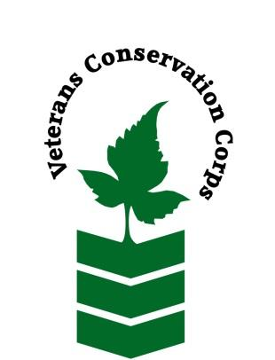
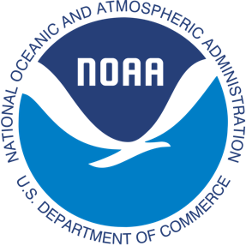
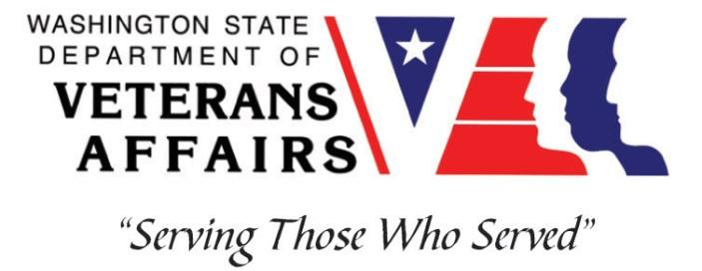
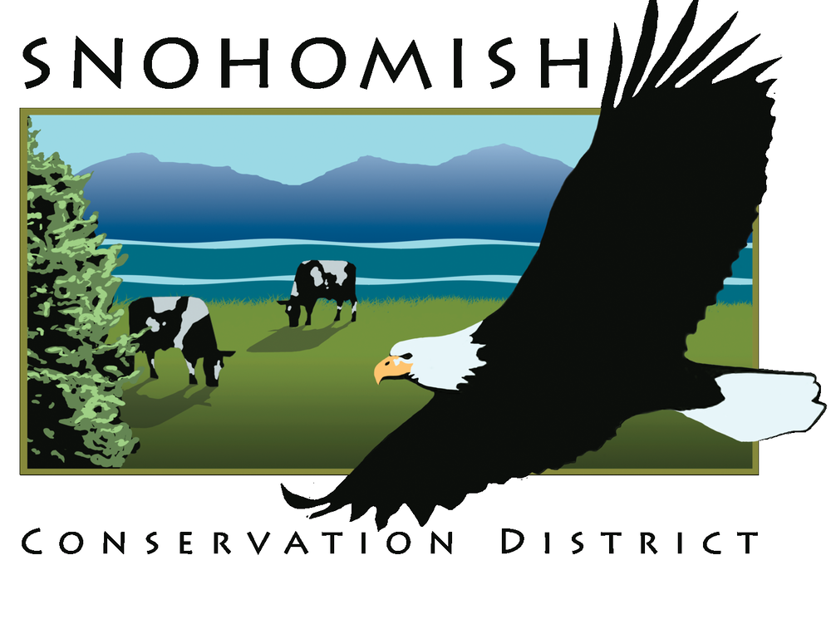

Snohomish Conservation District
528 91st Ave NE, Lake Stevens, WA 98258
425-335-5634
https://snohomishcd.org

NOAA WDVA Veterans Conservation Corps Fisheries Internship Program
with the
Snohomish Conservation District

***This position requires the applicant to be a veteran of the U.S. Uniformed Services***
Period of Performance: March-December 2023

Program Description
The NOAA WDVA Veterans Conservation Corps Fisheries Internship Program is a Washington-based internship focused on marine science and stewardship of coastal resources. Since 2016, NOAA has been funding these internships and partnering with the WDVA Veterans Conservation Corps to deliver high level science-based experiences at NOAA Research Centers and NOAA partner organizations throughout Washington. This internship adds Snohomish Conservation District (SCD) to this NOAA and WDVA Veterans Conservation Corps partnership. The internship will be supervised by SCD and located at the Lake Stevens office of the Snohomish Conservation District. The position will be supported and coordinated by the VCC and NOAA.

General Description
This position is with Snohomish Conservation District, a special purpose district of the State of Washington. Snohomish Conservation District’s mission is to work cooperatively with others to promote and encourage conservation and responsible use of natural resources. NOAA has collaborated with the Conservation District since 2011 in the development of the Snohomish Sustainable Lands Strategy. This effort encompasses the Stillaguamish and Skykomish-Snohomish River basins. The Conservation District provides technical assistance to the local agriculture community, implements salmon recovery and water quality protection projects, and supports community engagement in natural resource management. The Sustainable Lands Strategy is part of a network of efforts to restore fishery habitats while supporting agricultural production and reducing flood hazard in Puget Sound Floodplains.
Pacific Salmon are threatened with extinction caused by broad-scale ecosystem degradation. Puget Sound Rivers best sustain Pacific Salmon habitats where floodplains are forested with large old trees. Historically floodplain forests were destroyed and converted to agriculture. Remaining riverine forests are a thin patchwork of degraded stands and native forest remnants. This position will support SCD and NOAA in developing projects and programs to restore riparian forests using a biocultural restoration framework: restoring not only ecosystems, but human and cultural relationships to place, so that cultures are strengthened and revitalized along with the lands to which they are inextricably linked.
We aim to support community-based design and installation of complex riparian projects that restore historical habitat functions, while diversifying economic activity in ways that regenerate soils and biodiversity, protect water quality and quantity, and increase the general resilience and productivity of floodplain ecosystems.

Position Description

This position is supervised by Carrie Brausiek, Agroforestry & Senior Natural Resource Planner, Snohomish Conservation District, with support from the SCD team. The position will have regular contact and project support from Paul Cereghino, Restoration Ecologist, NOAA Restoration Center. The intern will have the opportunity to assist with diverse projects across the SCD and NOAA portfolio, and will:
- Assist nursery and field crews in nursery management, planting installation, and monitoring of agroforestry projects and native forest restoration.
- Assist the agroforester and restoration ecologist with field visits, project documentation and technical assistance in support of riparian restoration and agroforestry systems in Washington State.
- Assist in development and implementation of a Restoration Field Station for the design and installation of native riparian agroforestry prototypes, engaging both professionals and volunteers in site assessment, design and installation.
- Develop resources and site assessments to support the design of native riparian agroforestry systems in Snohomish County Floodplains.
Depending on interests and capabilities, we anticipate the intern will have the opportunity to design and develop products that fit personal capabilities and interests, and that directly fulfills program needs.

Schedule and Compensation

This internship will start on March 1, 2023 and begins with an initial 6-month term of service, with the opportunity to extend to one year at the discretion of SCD. It also includes a stipend of $2400/month to help cover living expenses for a full-time internship (~40 hours/week, four or five days each week, including occasional weekend and overnight field work activities). Alternative hours and flexible scheduling to meet the intern’s needs will be discussed on a case-by-case basis.
The position will be approximately 50% office based in Lake Stevens, WA with travel or field work opportunities comprising the remaining 50%. Due to COVID-19 health concerns, the position is likely to require remote work at times. The position does not provide housing. The SCD office is located in Lake Stevens, WA but field work will be implemented elsewhere in Snohomish County. Housing in parts of the County (Everett) can be expensive and hard to find. The office is accessible by public transportation, but field sites are not.

Required Skills, Knowledge, and Abilities

- This position requires the applicant to be a United States military veteran.
- Proficient with keyboarding and basic technical writing.
- Ability to learn plant species.

Preferred Skills, Knowledge, and Abilities.

Applicants that can demonstrate the following skills, knowledge, and abilities will be given preference:
- Motivated and enthusiastic, with an interest in riverine ecosystem restoration and conservation.
- Interest in the design of successional agroforestry systems, forest farming, and practical experimentation with the design and installation of complex vegetation.
- Interest in vegetation ecology, environmental horticulture, and plant species identification.
- Strong initiative and organization, ability to plan and host events, with attention to detail.
- Ability to work both independently and as a member of a team.
- Ability to enjoy multi-day field events while camping.
- Ability to read technical materials, develop questions and use colleagues and field observation to build knowledge about complex systems.
- Interest in rivers and floodplain dynamics.
- Experience with GIS or desktop publishing or digital photography or videography.

Physical Requirements:

- Ability to carry out physical labor outdoors in all weather conditions
- Able to lift and carry 50 lbs, crouch, bend, walk over rough or uneven terrain in all weather conditions
- Ability to follow appropriate safety practices in the field.
- Comply with SCD COVID protection protocols, including being fully vaccinated and providing documentation of vaccination status

Training
All necessary training required to perform the essential functions/duties is provided on the job.
In addition to on-the-job training, this position may include the following formal trainings and certifications to aid in personal and professional development and job training:
- Environmental conservation conferences/symposiums/workshops
- Provided by WDVA:
  - Posttraumatic Growth Training
  - PTSD/TBI/Mental Health/ Suicide Awareness & Prevention
  - Veteran Peer Support Training
  - VCC Annual Training (every August)

Apply
All applicants must pass a background check.
To apply, email a copy of your DD214 or service discharge certificate, a copy of your driver license, a resume, and a cover letter explaining your interest in this internship to:
Kim Pham
Veterans Conservation Corps Program Manager
kim@dva.wa.gov

Questions?
To learn more about the NOAA WDVA Veterans Conservation Corps Internship Program and NOAA’s partnership with the VCC, contact:
Kim Pham
Veterans Conservation Corps Program Manager
kim@dva.wa.gov

John Floberg
NOAA
Marine Habitat Resource Specialist
John.r.floberg@noaa.gov

For more information about this NOAA and Snohomish Conservation District position, contact:
Carrie Brausieck (SCD)
cbrausieck@snohomishcd.org
(703) 407-8341

Paul Cereghino (NOAA)
paul.r.cereghino@noaa.gov
206-948-6360

