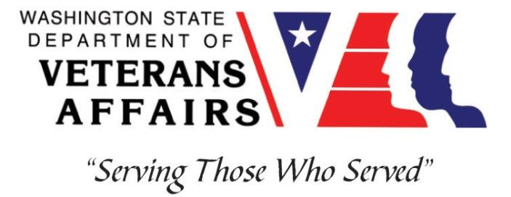
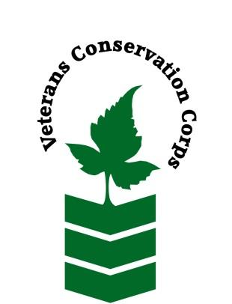
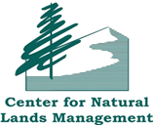

Center for Natural Lands Management – South Puget Sound Prairies
27258 Via Industria, Suite B. Temecula, CA 92590
Phone: (360) 480-6105
www.cnlm.org

Veterans Conservation Corps
with
Center for Natural Lands Management
Seed Production/Nursery Internship

Program Overview

The Center for Natural Lands Management (CNLM) was formed in 1990 as a nonprofit, 501(c)(3) organization, with a mission to provide perpetual stewardship for habitats and species of high conservation value. Current operations are in California and Washington, with more than 75 preserves, encompassing over 50,000 acres and new preserves added regularly. The preserves vary in size from three to thousands of acres and are managed under direct ownership, conservation easements, or management contracts.
In the State of Washington, CNLM's South Puget Sound Program focuses on conservation some of the most rare ecosystems in the United States, the prairie and oak woodlands of the Puget Sound Basin. The Program aims to protect and restore priority habitats and support recovery of rare species through collaboration and science-based conservation.
CNLM's Seed Production/Nursery team produces native seed with the goal of filling the seed needs of our restoration partners throughout Washington and Oregon. We produce seed of nearly 100 native plant species (including rare and endangered species) on 4 production sites, totaling 23 acres. The Native seed farm combines restoration efforts with traditional and small-scale agriculture to grow a diverse mix of native plants, we are always looking for new ways to refine our growing practices to best serve the community.

Position Summary

The Field Crew VCC member will have the opportunity to step into an exciting and unique agricultural system that has grown significantly over the past few years. The VCC member will help to assist in the production of native plant seeds and plugs for use in natural land restoration. The crew member’s time will be split among CNLM’s farms and nursery sites in South Thurston County and will have the opportunity to explore local restored prairies. The VCC member will work with a team consisting of CNLM staff, volunteers, AmeriCorps members and will closely work with a pervious Vet corps member who is now a full-time staff member.

We are looking for candidates with a positive attitude who are motivated, communicative, and hardworking and ready to jump in. Ideal candidates will gain experience in an agriculture, nursery, and conservation capacity. This person will join a diverse crew in performing tasks which include, but are not limited to weeding, harvesting seed, transplanting, seed cleaning and working one day a week with a volunteer group of wild seed scouters on the local prairies. Must be comfortable doing repetitive tasks over prolonged periods of time, adhering to proper tool use and body mechanics.

This position will provide on the job trainings and learning opportunities for the VCC member including:
- Operate farm equipment, such as tractors and seed cleaning machinery
- Identify native and invasive plants
- Learn about land conservation and restoration efforts in the South Puget Sound
- Learn how to grow and maintain small-scale beds and row crop production
- Scout native plant populations
- Help lead volunteer groups and workshops
This position has some flexibility to fit to the interests of applicants to provide the best experience for the VCC member.

Schedule and Compensation

This 6-month internship, with possibility of extension, begins in March 2023 and includes a VCC stipend of $2400/month for a full-time internship (~40 hours/week) or $1200/month for a part-time internship (~20 hours/week) to help cover living expenses. Position open until filled.

Monday through Friday from 8am to 4pm. Main location will be at Violet Prairie Native Seed Farm: 17842 Gibson RD SW, Tenino, WA 98589.

Requirements

- This position requires the applicant to be a veteran of the United States Uniformed Services to be eligible for this position

Preferred Knowledge, Skills, and Abilities

This is considered an entry level position and no experience is required. Applicants with the following skills, knowledge, and abilities will be given preference:

- Excellent communication skills
- Ability to do repetitive tasks over prolonged periods of time
- Detail-oriented
- Ability to ask for direction as needed
- Comfortable working with minimal direct supervision
- Excellent interpersonal skills and willingness to work with a diverse group of people
- Positive attitude in all types of weather
- Interest in Native plant, general ecology, prairies, habitat restoration or agriculture

Working Conditions

- Regularly works in natural areas, at times during adverse conditions (e.g. summer heat and sun). Hikes across, and conducts work within, native habitats and uneven ground.
- Regularly required to operate a CNLM vehicle.
- Use of farm equipment and machinery such as tractors, weed whackers, leaf blowers.
- Uses hand tools.
- Regularly lifts, positions, or otherwise moves objects weighing up to 50 pounds.
- Frequent bending, kneeling and repetitive movements.

Training

All necessary training required to perform the essential functions/duties is provided on the job.
In addition to on-the-job training, this position may provide the following formal trainings and resources to aid in personal & professional development:
- Veterans Cultural Engagement Training
- Posttraumatic Growth Training
- PTSD/TBI/Mental Health/ Suicide Awareness & Prevention
- WDVA Veteran Peer Corps Certification
- Environmental conservation conferences/symposiums/workshops
- Other trainings/certifications as available and desired by intern

Apply

All applicants must pass a background check.

To apply, email a resume, a copy of your DD214 or service discharge certificate, a copy of your current driver’s license, and a cover letter explaining your interest in this internship to:

Kim Pham
Veterans Conservation Corps Program Manager
kim@dva.wa.gov

Questions?

To learn more about the Veterans Conservation Corps Internship Program, contact:

Kim Pham
Veterans Conservation Corps Program Manager
kim@dva.wa.gov

For more information about the Center for Natural Lands Management, contact:

Anika Goldner
Nursery Program Supervisor
agoldner@cnlm.org
(360) 480-6105

