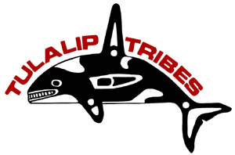
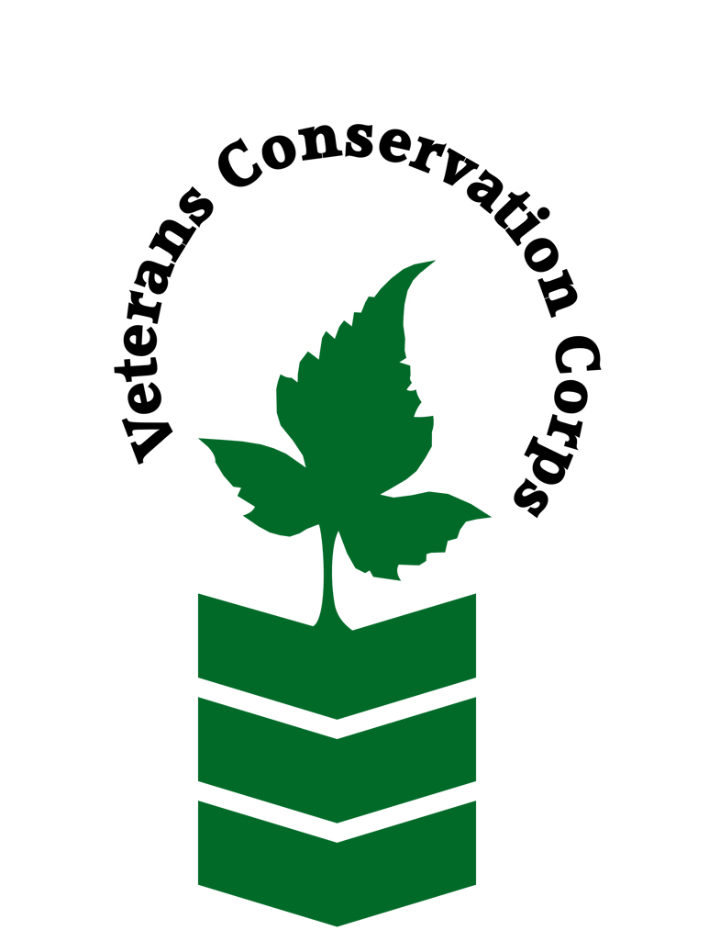

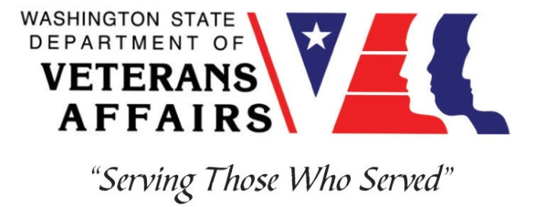

6406 Marine Drive, Tulalip, WA 98271
https://nr.tulaliptribes.com/

Veterans Conservation Corps
with
Tulalip Tribes Natural Resources Department
Field Projects Program Internship

***This position requires the applicant to be a veteran of the U.S. Uniformed Services***

Program Overview

The Tulalip Tribes Natural Resources Department is tasked with monitoring, managing, restoring, and protecting the Tribes treaty right resources within their usual and accustomed territories. The Field Projects Program within the Natural Resources Department is tasked with conducting research and monitoring to evaluate restoration designs and performance as well as conducting research to identify restoration opportunities and identify things impacting the Tribes’ treaty resources.

Position Summary

The Tulalip Tribes Natural Resources Department Field Projects Program conducts research and monitoring on out migrating juvenile salmon in the Skykomish and Snoqualmie Rivers, the Snohomish estuary, and the marine waters of the Puget Sound.
This position will assist with data collection in the Snohomish Estuary, Puget Sound, and in small streams draining to the Puget Sound using a variety of techniques including beach seining, fyke nets, and electrofishing. The person in this position will learn the different monitoring and sampling techniques, why we use them and will also learn how to identify juvenile salmon and other fish species.
Duties will include setting and pulling in fishing nets, sorting, counting and measuring fish by species, assisting in other sampling efforts and techniques. The position will also likely be assisting with electrofish sampling, and other fish and habitat assessment work. The position will also assist with boat and equipment maintenance and care and follow the direction of the supervising Field Biologist (Team Leader).

Duties and Responsibilities

- Assist with beach seining salmonid surveys in the Snohomish River estuary, and Puget Sound Marine Nearshore
- Assist in the collection and processing of fish catches
- Record catch by species, conditions, fishing times and other parameters
- Assist with boat and equipment maintenance and care
- Work as a team with others assigned to the project
- Follow directions of Marine & Nearshore Program Manager and Field Biologist (Team Lead)
- Ensure that safety procedures are adhered to during field sampling
- Perform other duties as deemed necessary

Schedule and Compensation

This 6-month internship, with possibility of extension, begins in February 2024 and includes a VCC stipend of $2,400/month for a full-time internship (~40 hours/week) or $1,200/month for a part-time internship (~20 hours/week) to help cover living expenses. Monday through Friday from 8am to 4:30pm, with occasional extended field days. Alternative hours and flexible scheduling to meet the intern’s needs will be discussed on a case-by-case basis. This position will remain open until filled.

Requirements

- This position requires the applicant to be a veteran of the United States Uniformed Services
- Current valid Washington State driver's license
- Must be able to work long flexible hours including early mornings and potentially late evenings and have the ability to tolerate cold weather and harsh/difficult working conditions

Preferred Qualities

Minimum qualifications are not established for this position; however, applicants with the following skills, knowledge, and abilities will be given preference:
- Good communication and writing skills
- Experience in fish identification
- Experience operating and maintaining scientific sampling equipment.
- Washington State Boater Education Card or approved USCG Boating Class or equivalent armed services documentation.
- Experience operating watercraft (small boats with outboard engines, kayaks, etc.)
- Working knowledge of ArcGIS.
- Familiarity with Microsoft office programs (Word, Excel, PowerPoint, etc.)

Physical Requirements

- Comfortable working in adverse terrain including mudflats, streams, beaches, marshes, and forests
- Spending extended periods of time exposed to the elements and wading in rivers and along shorelines
- Capable of carrying 40 pounds (nets and 5-gallon buckets full of fish and water)
- Able to stand and/or walk for 8-10 hour shifts in challenging terrain and weather

Training

All necessary training required to perform the essential functions/duties is provided on the job.

In addition to on-the-job training, this position may include the following formal trainings and resources to aid in personal & professional development:
- Electrofishing certification
- Watercraft operation training (small boats with outboard engines, kayaks, etc.)
- Basic first aid, CPR, and safety training
- Fish and vegetation identification training
- Posttraumatic Growth Training
- PTSD/TBI/Mental Health/ Suicide Awareness & Prevention
- Veteran Peer Support Training
- Environmental conservation conferences/symposiums/workshops
- Other trainings/certifications as available and desired by intern

Apply

To apply, email a resume, a copy of your DD214 or service discharge certificate, a copy of your current driver’s license, and a cover letter explaining your interest in this internship to:

Kim Pham
Veterans Conservation Corps Program Manager
kim@dva.wa.gov

Questions?
To learn more about the Veterans Conservation Corps, contact:

Kim Pham
Veterans Conservation Corps Program Manager
kim@dva.wa.gov

For more information about the Tulalip Tribes Field Projects Program, contact:

Todd Zackey
Field Projects Program Manager
tzackey@tulalipgtribes-nsn.gov
(360) 716-4637

