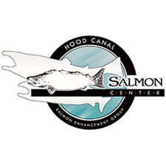
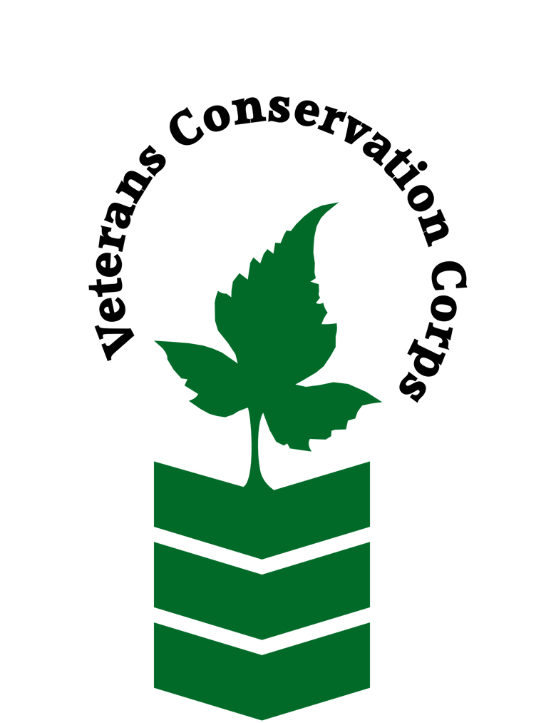

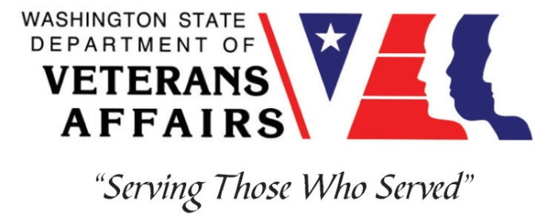

600 NE Roessel Rd, Belfair, WA 98528
www.pnwsalmoncenter.org

Veterans Conservation Corps
with
Hood Canal Salmon Enhancement Group
Field Research and Stewardship Internship

***This position requires the applicant to be a veteran of the U.S. Uniformed Services***

Program Overview

The Hood Canal Salmon Enhancement Group (HCSEG) strives to deepen the connection between land, people, and salmon through restoration, education, and research. Our mission is to ensure that wild salmon are once again abundant in the Pacific Northwest.

Position Summary

HCSEG performs salmon and steelhead research on the Union, Tahuya, Dewatto, and Little Quilcene rivers in the spring and and late summer to monitor ESA-listed summer chum and steelhead populations to assist the state with fisheries forecasting as well as to evaluate the effects of habitat restoration, climate change, and urban growth in the Hood Canal watershed. HCSEG also conducts a wide range of riparian restoration, educational outreach, and sustainable agriculture activities throughout the spring and summer.

This position primarily involves field activities and data entry during salmon and steelhead migration seasons. Duties will include summer chum, steelhead, and coho abundance monitoring, tissue sampling for genetic and age analysis, in-stream surveys, as well as rotary screw and weir trap installation and operation. Outside of migration seasons, the position may involve assisting our Riparian Stewardship team in performing invasive plant removal, our Stream Team in performing stream surveys, our Americorps team in performing education and outreach, or assisting our Farm manager in performing sustainable agriculture and animal care depending on workload and the interests of the intern.

Duties and Responsibilities

- Assist with juvenile rotary screw and adult weir trap operations
- Assist with species identification and enumeration
- Record catch by species, sex, life stage, and other parameters
- Perform carcass surveys for adult summer chum
- Assist with habitat restoration projects including invasive plant control
- Assist with education and outreach projects
- Perform daily farm and animal care
- Work as a team with other staff and volunteers assigned to the projects
- Follow directions of Salmon and Steelhead Biologist, Stewardship Manager, Stream Team Supervisor, Education and Outreach Coordinator, or Farm manager
- Ensure that safety procedures are adhered to during field activities
- Perform other duties as deemed necessary

Schedule and Compensation

This 7-month internship, with possibility of extension, begins in April 2024 and includes a VCC stipend of $2,400/month for a full-time internship (~40 hours/week) or $1,200/month for a part-time internship (~20 hours/week) to help cover living expenses. Monday through Friday from 8am to 4:30pm, with occasional extended field days. Alternative hours and flexible scheduling to meet the intern’s needs will be discussed on a case-by-case basis. This position will remain open until filled.

Requirements

- This position requires the applicant to be a veteran of the United States Uniformed Services
- Current valid Washington State driver's license
- Must be able to work long flexible hours including early mornings and potentially late evenings and have the ability to tolerate cold weather and harsh/difficult working conditions
- Must be comfortable working with volunteers of all ages and abilities

Preferred Qualities

Minimum qualifications are not established for this position; however, applicants with the following skills, knowledge, and abilities will be given preference:
- Good communication and writing skills
- Experience in fish and plant identification
- Experience operating and maintaining scientific sampling equipment
- Experience collecting biological samples
- Working knowledge of ArcGIS
- Familiarity with Microsoft office programs (Word, Excel, PowerPoint, etc.)

Physical Requirements

- Comfortable working in adverse terrain including mudflats, streams, beaches, marshes, and forests
- Spending extended periods of time exposed to the elements and wading in rivers and along shorelines
- Capable of carrying 40 pounds (nets and 5-gallon buckets full of fish and water)
- Able to stand and/or walk for 8-10 hour shifts in challenging terrain and weather

Training

All necessary training required to perform the essential functions/duties is provided on the job.

In addition to on-the-job training, this position may include the following formal trainings and resources to aid in personal & professional development:
- Rotary Screw and Weir Trap operation training
- Fish and vegetation identification training
- Salmonid life history and DNA sampling training
- Herbicide application training
- Posttraumatic Growth Training
- PTSD/TBI/Mental Health/ Suicide Awareness & Prevention
- Veteran Peer Support Training
- Environmental conservation conferences/symposiums/workshops
- Other trainings/certifications as available and desired by intern

Apply

To apply, email a resume, a copy of your DD214 or service discharge certificate, a copy of your current driver’s license, and a cover letter explaining your interest in this internship to:

Kim Pham
Veterans Conservation Corps Program Manager
kim@dva.wa.gov

Questions?
To learn more about the Veterans Conservation Corps, contact:

Kim Pham
Veterans Conservation Corps Program Manager
kim@dva.wa.gov

For more information about the Hood Canal Salmon Enhancement Group, contact:

Joshua O’Hara
Salmon and Steelhead Biologist
josh@pnwsalmoncenter.org
(360) 275-3575 ext. 115

