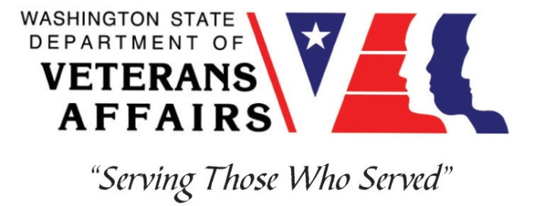
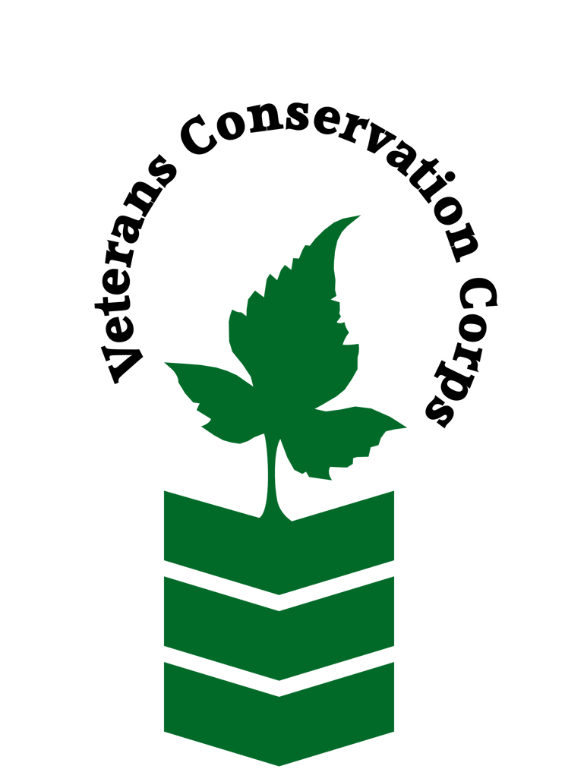

Center for Natural Lands Management – South Puget Sound Prairies
120 Union Avenue, SE #215, Olympia, WA 98501
Phone: (360) 464-1024
www.cnlm.org

Veterans Conservation Corps
with
Center for Natural Lands Management
Seed Production/Nursery Internship

General Description

The Center for Natural Lands Management (CNLM) was formed in 1990 as a nonprofit, 501(c)(3) organization, with a mission to provide perpetual stewardship for habitats and species of high conservation value. Current operations are in California and Washington, with more than 75 preserves, encompassing over 50,000 acres and new preserves added regularly. The preserves vary in size from three to thousands of acres and are managed under direct ownership, conservation easements, or management contracts.
In the State of Washington, CNLM's South Puget Sound Program focuses on conservation some of the most rare ecosystems in the United States, the prairie and oak woodlands of the Puget Sound Basin. The Program aims to protect and restore priority habitats and support recovery of rare species through collaboration and science-based conservation.
CNLM's Seed Production/Nursery team produces native seed with the goal of filling the seed needs of our restoration partners throughout Washington and Oregon. We produce seed of nearly 100 native plant species (including rare and endangered species) on 4 production sites, totaling 23 acres.

Position Description

The Field Crew Member (Seed Production Technician) will have the opportunity to step into an exciting and unique agricultural system that has grown significantly over the past few years. We are looking for candidates with a positive attitude who are motivated, communicative, and hardworking and ready to jump in. Ideal candidates will gain experience in an agriculture, nursery, and conservation capacity. This person will join a diverse crew in performing tasks which include, but are not limited to weeding, harvesting seed, transplanting and possibly seed cleaning. Must be comfortable doing repetitive tasks over prolonged periods of time, adhering to proper tool use and body mechanics

This 3-month internship begins in June 1, 2020 and includes a stipend of $2000/month to help cover living expenses. This internship requires a commitment of up to 40 hours/week.

Requirements

This position requires the applicant to be a United States military veteran. Minimum qualifications are not established for this position; however applicants with the following skills, knowledge, and abilities will be given preference.

- Excellent communication skills
- Ability to do repetitive tasks over prolonged periods of time
- Detail-oriented
- Ability to ask for direction as needed
- Comfortable working with minimal direct supervision
- Excellent interpersonal skills and willingness to work with a diverse group of people
- Positive attitude in all types of weather
- Sense of humor
- Willingness to use herbicide as needed (minimally)

Working Conditions

- Regularly works in natural areas, at times during adverse conditions (e.g. summer heat and sun). Hikes across, and conducts work within, native habitats and uneven ground.
- Regularly required to operate a CNLM vehicle.
- Uses pesticides and or other chemical substances.
- Use of farm equipment such as tractors.
- Uses hand tools
- Regularly lifts, positions, or otherwise moves objects weighing up to 50 pounds.
- Frequent bending, kneeling and repetitive movements

Training

All necessary training required to perform the essential functions/duties is provided on the job.

In addition to on-the-job training, this position may include the following formal trainings and certifications to aid in personal & professional development:

- CPR/First Aid
- Posttraumatic Growth Training
- PTSD/TBI/Mental Health/ Suicide Awareness & Prevention
- WDVA Veteran Peer Corps Certification
- Vet Corps Annual Training (every August)
- VCC Annual Training & Retreat (every July or August)
- Resume/cover letter/job interviews

Apply

All applicants must pass a background check.

To apply, email a resume, a copy of your DD214, a copy of your current driver’s license, and a cover letter explaining your interest in this internship to:

Kim Pham
Veterans Conservation Corps Program Specialist
kim@dva.wa.gov

Questions?
To learn more about the Veterans Conservation Corps, contact:
Kim Pham
Veterans Conservation Corps Program Specialist
kim@dva.wa.gov

For more information about the Center for Natural Lands Management, contact:

Andy Hopwood
Nursery Manager
ahopwood@cnlm.org

