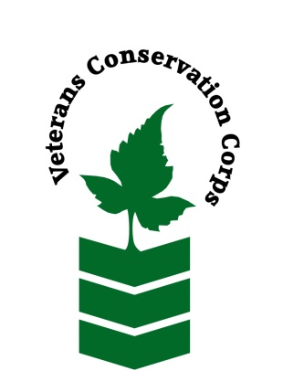
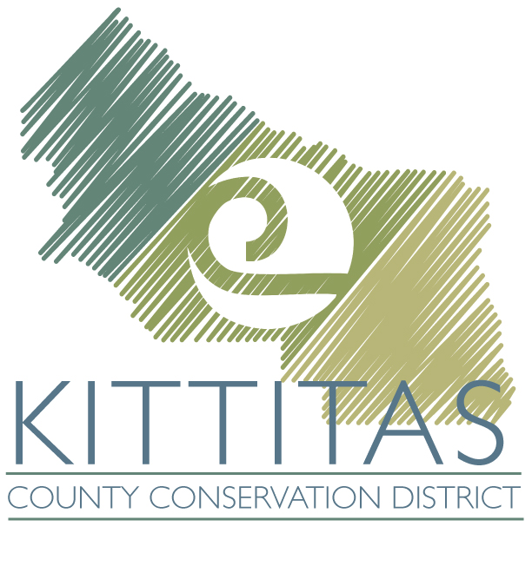

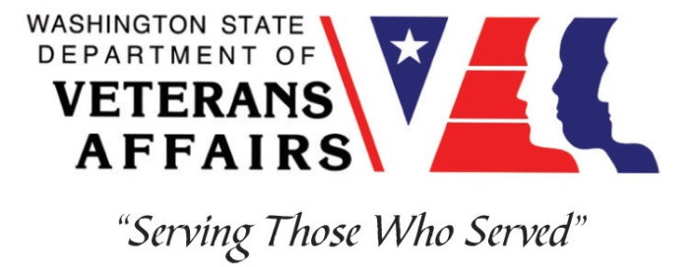

KCCD, 2211 W Dolarway Road, Suite 4, Ellensburg WA 98926
Phone 509-925-3352
www.kccd.org

Veterans Conservation Corps
with the
Kittitas County Conservation District
Field Crew Internship

Position Summary
This position will work on a 2 to 3-person field crew under the supervision of the Kittitas County Conservation District (KCCD). The crew will primarily work with landowners on wildfire fuels mitigation within the Wildland Urban Interface of Kittitas County through a roving chipper program with some direct fuels removal (cutting, limbing, etc) and disposal. The crew will also work with landowners on riparian and wildlife planting projects by clearing and preparing planting areas and then planting and maintaining trees and shrubs; and other outdoor work related to KCCD projects and priorities.

- Work week is Monday-Thursday, 7am-5pm
- Includes a $1,800 monthly stipend to assist with living expenses
- 5-month term (June 1st - October 30th)
- All safety equipment (gloves, hard hats, eye protection, ear protection, etc.) is provided

Requirements
- Must be a United States military veteran to be eligible for this position
- Must have dependable transportation to and from the Kittitas County Conservation District office
- Must currently possess or be able to obtain a valid driver’s license
- Must be able to work Monday-Thursday, 7am-5pm

Preferred Knowledge, Skills, and Abilities
This is considered an entry level position and no experience is required. Applicants with the following skills, knowledge, and abilities will be given preference.
- Experience working on a crew to perform time-sensitive construction projects on private and public property
- Experience implementing safety practices in the field with and without supervision
- Experience operating a wood chipper or similar equipment
- Experience operating hand tools and power tools, especially chain saw and other tree and shrub limbing and thinning equipment
- Experience in landscape construction
- Able to lift up to 50-lbs
- Able to consistently perform hard labor in all outdoor conditions
- Able to take direction and work as a member of a team
- Able to operate a motor vehicle and haul a trailer or wood chipper
- Motivated and enthusiastic
- Comfortable speaking to landowners and other members of the public about projects

Training
All necessary training required to perform the essential functions/duties is provided on the job.

In addition to on-the-job training, this position may include the following formal trainings and certifications to aid in professional development and job training:

- Chain saw training
- VCC orientation
- CPR/First Aid
- Posttraumatic Growth Training
- PTSD/TBI/Mental Health/Suicide Awareness Training
- WDVA Veteran Peer Corps Certification
- VCC Annual Training (every August)
- Resume/cover letter/job interviews

Apply
All applicants must pass a background check. To apply for this internship, email a copy of your DD214 and driver license, a resume, and a cover letter explaining your interest in this internship to:

Kim Pham
Veterans Conservation Corps Program Specialist
kim@dva.wa.gov

Questions?
To learn more about the Veterans Conservation Corps, contact:

Kim Pham
Veterans Conservation Corps Program Specialist
kim@dva.wa.gov

For more information about the job requirements, contact:

Anna Lael
Kittitas County Conservation District
a-lael@conservewa.net
509.925.3352 ext 207

