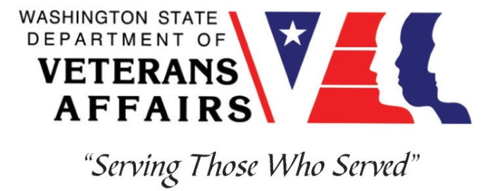
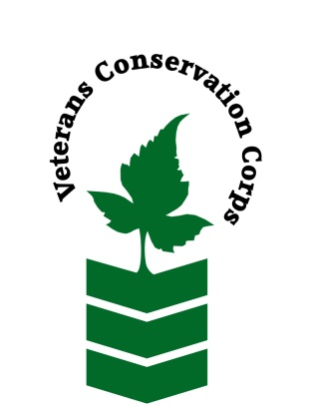

Veterans Conservation Corps
Veterans Farm at Orting
Farm Internship

Overview

The Veterans Farm at Orting is located at the WA State Department of Veterans Affairs’ Soldiers Home in Orting, WA. The farm consists of 6 individual half-acre parcels, of which three acres are fenced, that can be leased to veterans who are interested in farming, with the potential growth of an additional five acres in the near future. The farm has a greenhouse, storage for tools, and an on-site walk-in cooler for cold storage of crops. In addition, an adjacent wetland native plant habitat will be restored and protected.

Position Summary

The farm intern(s) will discover and/or enhance their skills in the vast world of agriculture by supporting farm operations with the Farm Manager and the veterans leasing plots on the farm. In addition, the intern(s) will assist in the growth of farm programming and the development of new farmland, as well as assist with established projects throughout the farm. Exposure to marketing, relationship-building, and small-business development will be included. The farm internship will also be custom-designed to meet the intern’s educational objectives pertaining to agriculture topics.

Hours and Compensation

This is a 6-month internship, with the possibility for an extension to one year, that will require approximately 40 hours per week, and includes a stipend of $1800/month to assist with living expenses.

Responsibilities

Daily Operations
- Check-in daily with Farm Manager regarding scheduled activities and projects
- Operate necessary equipment with safety and care
- Responsible tool use and maintenance
- Daily log/mapping of intern projects

Educational Opportunities
- Learn techniques in row-cropping, fruit-tree production, berries, flowers and herbs, livestock, and other aspects of farming
- Become well versed in the use of and maintenance of equipment (i.e. tractors, implements, and other equipment)
- Learn and understand the importance of water use in irrigation systems

Marketing and Small-Business Development
- Learn from experts in the field (through Cultivating Success and/or Enterprise for Equity)
- Be an active team member by working closely with the farm manager to communicate ideas, identify potential problems, provide feedback, and offer creative solutions
- Attend weekly farm meetings

Additional Perks:
- You get to work with knowledgeable staff in an amazing location
- You get to work outside most of the time!
- You will be involved in farm gatherings centered around food, especially at lunch, but also with team-building-events

Training
All necessary training required to perform the essential functions/duties is provided on the job.

In addition to on-the-job training, this position may include the following formal trainings and certifications to aid in personal & professional development:

- CPR/First Aid
- Posttraumatic Growth Training
- PTSD/TBI/Mental Health/ Suicide Awareness & Prevention
- WDVA Veteran Peer Corps Certification
- Vet Corps Annual Training (every August)
- Resume/cover letter/job interviews

Requirements
- Must be a United States military veteran
- Must have the capacity to work efficiently alone and in a team
- Must be able to lift 40 lbs or more
- Must have a valid driver’s license
- The successful candidate possesses:
  - Strong customer service and people skills
  - Ability to work and think under time pressure
  - Willingness and skill to give and receive feedback
  - A passion for local agriculture, small business, and community food systems
  - A great sense of humor is also a plus

Apply

All applicants must pass a background check.

To apply, email a resume, a copy of your DD214, a copy of your current driver’s license, and a cover letter explaining your interest in this internship to:

Kim Pham
Veterans Conservation Corps Program Specialist
kim@dva.wa.gov

Questions?
To learn more about the Veterans Conservation Corps, contact:
Kim Pham
Veterans Conservation Corps Program Specialist
kim@dva.wa.gov

For more information about the Veterans Farm at Orting contact:
Carrie Little
Farm Manager, Veterans Farm at Orting
Carrie.little@dva.wa.gov

