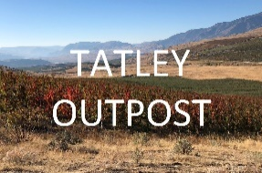
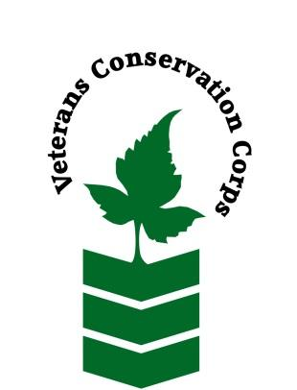
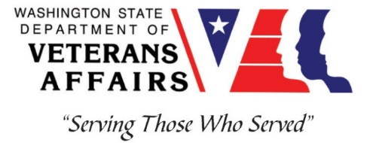

Veterans Conservation Corps
Tatley Outpost Ranch Hand Internship
Overview
Tatley Outpost is a 1,600-acre farm and ranch in Pateros, WA that is ran and operated by Veterans. Our mission at Tatley Outpost is simple and ambitious, "Provide opportunities for Veterans to create global impact through a community approach". We are driven by our passions to build sustainable agriculture that preserves the land and our natural resources, enjoy everything nature has to offer and preserve its beauties for generations to come, build a greater sense of community where we are all helping one another – and in the end we will collectively Make the World a Better Place.

At the center of our operation is a sizeable and diverse orchard and farm. We surround the orchard and farm operation with training, healing, outdoor adventures, and other programs. Our apple and cherry orchard represent our core crops, that are then complemented by row crops, green houses, and livestock. We seek to grow a wide range of crops, such as tomatoes, mushrooms, hops, peppers, various herbs, and more. Additionally, we have integrated pigs, sheep and chickens into our ranch and with the large acreage, there is always plenty to do. We believe our diversity creates a great ecosystem, while providing variety in day to day activities and more learning opportunities. Learn more at www.TatleyOutpost.com.

Position Summary:
The Farm Hand Intern reports to the Owner and will assist them across the spectrum of running and maintaining the farm and ranch. This will be a critical role in supporting the expansion and growth of the operation. The position is a full-time position working through an entire season. The growing season typically runs from March 1st through the end of November. Work weeks are generally Monday through Friday, 7 am to 3 pm. However, during harvest time, work days may vary and require weekend work. Hours of the day can vary depending on weather conditions (e.g. too cold in the mornings may require later starts, or too hot in the afternoon may require earlier starts).

This is a 6-month internship that includes a stipend of $1800/month for a full-time internship (approximately 40 hours/week) to help cover living expenses.

Main tasks include:
- Own landscaping and maintenance such as: mowing, weed whacking, flowers, irrigation, fencing, and gates.
- Own garbage and recycling program, disposal management, and lead the charge to create a zero-waste operation.
- Own organization and cleaning of equipment and supplies.
- Lead the coordination in various building and infrastructure projects, which may include trellising, greenhouse building/modification, storage expansion, fire pit, training bleachers, shade and wind barriers, and other infrastructure management and maintenance.

Other Duties may include:
- Participate in community outreach events and funding events as needed
- Implementation of solar panels
- Implementation of water filtration system
- Assist other farmers with harvest activities and organization
- Other conservation program and administrative duties assigned by Owner
- Other duties as assigned by Owner

Qualifications:
- This position requires the applicant to be a United States military veteran
- Good, clear communication skills, active listening skills, able to engage with the community to talk about Tatley Outpost mission
- If no experience with farming, at least a high interest in the field and motivation to feed our communities
- Valid Driver’s license
- Experience with Microsoft Word, Excel, and OneDrive (or equivalent file sharing)
- Ability to work independently in the field while demonstrating a strong work ethic and safety common sense
- Ability to work as part of a team of staff and/or community volunteers in the field
- Ability to meet and work with new people
- Ability to act as a leader and uphold high ethical standards
- Excellent communication skills
- Excellent attention to detail
- Willingness to learn new skills
- Love of the nature and the outdoors

Physical Requirements:
- Physically able to conduct demanding field work and traverse occasionally rough terrain in a variety of weather conditions
- Ability to lift up to 40 pounds
- Not afraid to get dirty
- Ability to operation tools, such as: larger mowers, tractors, chain saw, and power tools
- Able to work in adverse weather

Training
All necessary training required to perform the essential functions/duties is provided on the job.

There will also be industry training available from our industry, community and non-profit partners to participate in.

In addition to on-the-job training, this position may include the following formal trainings and certifications to aid in personal & professional development:

● CPR/First Aid
● Posttraumatic Growth Training
● PTSD/TBI/Mental Health/ Suicide Awareness & Prevention
● WDVA Veteran Peer Corps Certification
● VCC Annual Training
● Resume/cover letter/job interviews

Apply

All applicants must pass a background check.

To apply, email a resume, a copy of your DD214, a copy of your current driver’s license, and a cover letter explaining your interest in this internship to:
Kim Pham
Veterans Conservation Corps Program Specialist
kim@dva.wa.gov

Questions?
To learn more about the Veterans Conservation Corps, contact:
Kim Pham
Veterans Conservation Corps Program Specialist
kim@dva.wa.gov

For more information about Tatley Outpost, contact:
David Overcash Tim Andrews
Chairman Operations Manager
david@goldenacts.com saltybeardart@gmail.com
(425) 478-3790 (951) – 541-4591

