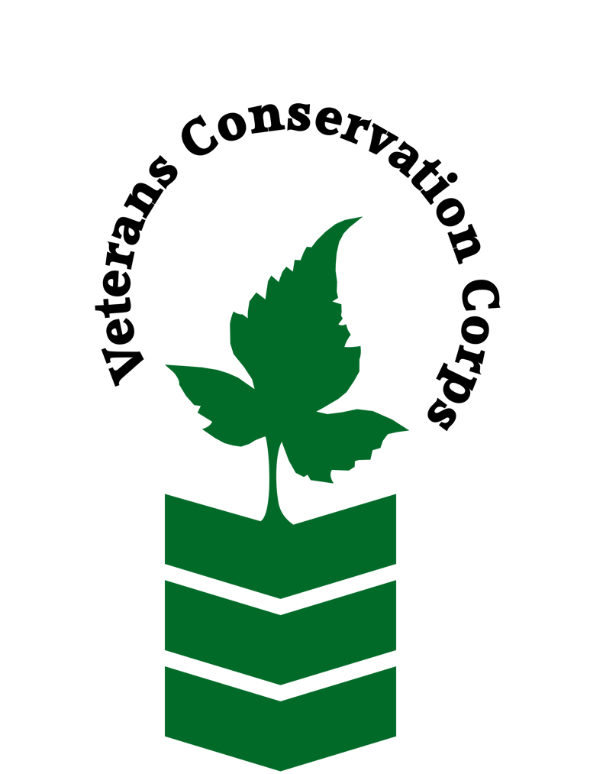
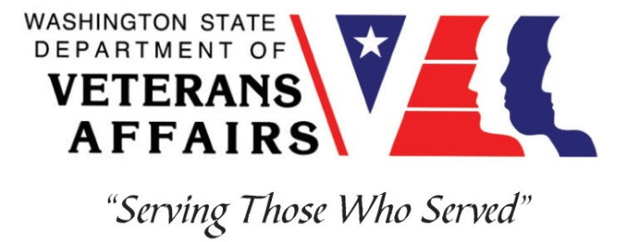
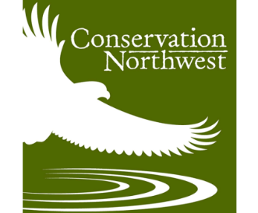

1829 10th Ave W. Suite B
Seattle, WA 98119
www.conservationnw.org

Veterans Conservation Corps Internship Program
with
Conservation Northwest

General Description

Conservation Northwest is an environmentally focused non-profit, working on connecting the big landscapes, restoring iconic wildlife and protecting our natural heritage for future generations. From the Washington Coast to the British Columbia Rockies, we are a voice for conserving wildlands and wildlife.

Wildlife are on the move in the Pacific Northwest. They make daily movements to find food and mates, seasonal migrations as conditions change, and generational shifts claiming new territory to call home. Habitat connectivity becomes even more important as the climate changes and animals move to adapt to a changing environment. Restoring habitat connectivity has been a cornerstone of Conservation Northwest’s work since our founding in 1989. By focusing on connecting the big landscapes, we’ve successfully protected vital wildlife corridors and reconnected habitat between Washington’s North and South Cascades, from the British Columbia Coast and Chilcotin Ranges to the North Cascades, from the Cascades to the Kettle River Range and Greater Rocky Mountains, and more. We provide regional leadership on both sides of the U.S.-Canada border to protect the connection between habitat patches and even large landscapes.

Through our Cascades to Olympics Program we work to restore habitat and improve wildlife connectivity between Washington’s Cascade Range and the Olympic Peninsula. This work takes many forms; engaging in scientific studies (modeling, camera trapping), working with landowners, working and collaborating with state and federal agencies, working with Tribes, media outreach, and teaming up with other non-profit partners, to advocate, facilitate, fund, coordinate and implement on-the-ground actions that can improve habitat connectivity for native species.

Position Description

Conservation Northwest’s (CNW) Cascades to Olympics Program is seeking a motivated, self-starter to help with an ongoing wildlife camera monitoring project. This project brings together CNW’s Community Wildlife Monitoring Program and the Veterans Ecological Trades Collective to monitor and enhance a known wildlife corridor. This internship will give qualified applicants an opportunity to become involved with and learn about wildlife conservation, habitat connectivity, non-profit collaboration, field work, camera trapping, biology, GIS mapping products, and environmental science/studies.

Schedule and Compensation

This 6-month internship will begin June 1, 2021 (position open until filled), and includes a VCC stipend of $900/month for a part-time internship (~20 hours/week) to help cover living expenses.

There is no “typical” work week schedule, due to the nature of the work and the ability to work from home, this position can be extremely flexible. Intern will work closely with the site supervisor and the landowner to work out a schedule that works for all parties.

Work to Be Performed

While 50 percent of the work can be performed from home, the intern will be expected to travel to the site location (20 miles south of Olympia) at least twice a week. Access to internet and computer at home are a major plus for this position.

Intern will likely spend 75 % of their time working on data management and photo identification, for both the target location and for photos collected in other parts of the state by the Community Wildlife Monitoring Program, and maintaining camera traps. Intern will likely spend 25 % of their time reading relevant documents, exploring online GIS tools, and attending relevant meetings and work groups when available.

- Assist in placing, maintaining, and checking wildlife cameras in an outside environment.
- Read studies, articles, and interact with online GIS maps related to habitat connectivity.
- Sort and manage large sets of photograph data, removing false triggers, and identifying species
- Attend occasional Zoom meetings.
- Interact with and join the Community Wildlife Monitoring Program.
- Flexible scheduling.
- Intern will need access to a computer at home, with reliable internet and photo editing/viewing capabilities.

Learning Outcomes

- Will learn methodologies and techniques for wildlife camera monitoring.
- Gain the ability to identify local wildlife species.
- Learn to manage large sets of data.
- Gain an understanding of how on-the-ground science is used in larger landscape level conservation.
- Learn how the Community Wildlife Monitoring Program operates and contributes to regional scientific and conservation efforts.
- Gain an understanding of the overlap between wildlife camera data and habitat connectivity.
- Obtain firsthand experience of how local non-profit organizational partnerships work.
- Learn how conservation is achieved through science.

Progress Monitoring

- Intern will draft a 1-2 page bi-weekly report describing key takeaways and learning objective insights and progress. This will be sent to both the Conservation Northwest field supervisor and landowner.
- Intern will check-in with the field supervisor by phone weekly, to discuss concerns, ask questions and get updates.
- Field supervisor will be responsible for generating an evaluation for the intern throughout the internship and at the end as well.
COVID-19 guidelines for on-site visits

- The intern and all persons at the site, are required to wear a mask
- No more than state suggested number people will be present at the same time at the field site

Onsite Protocols
- Intern will be given access to our conservation partner’s property, via a security gate pass code
- Intern will log onsite hours behind the gate, sending them to the field supervisor
- Intern will also report onsite hours in the bi-weekly progress report

Requirements

- Must be a United States military veteran to be eligible for this position.
- Must possess the ability to work on their own, take initiative, and be reliable.
- Must have access to a computer at home, with reliable internet and photo editing/viewing capabilities.
- Must be flexible as work description may change slightly as new data or information become available.

Preferred Knowledge, Skills, and Abilities

This is considered an entry level position and no experience is required. However applicants with the following skills, knowledge, and abilities may be given preference:

- Have excellent communication skills
- Have a passion for environmental work
- Have the ability to sort through large datasets
- Have a basic understanding of wildlife biology and landscape ecology
- Have a basic understanding or experience using wildlife cameras

Training

All necessary training required to perform the essential functions/duties is provided on the job.

In addition to on-the-job training, this position may include the following formal trainings and certifications to aid in personal & professional development:

- Veterans Cultural Competency Training
- CPR/First Aid
- Posttraumatic Growth Training
- PTSD/TBI/Mental Health/ Suicide Awareness & Prevention
- WDVA Veteran Peer Corps Certification
- VCC Annual Training (every August)
- Environmental conservation conferences/symposiums/workshops
- Growing your veteran-owned small business
- Whole Farm Planning and Agricultural Entrepreneurship
- Other trainings/certifications as available and desired by intern

Apply

All applicants must pass a background check.

To apply, email a resume, a copy of your DD214, a copy of your current driver’s license, and a cover letter explaining your interest in this internship to:

Kim Pham
Veterans Conservation Corps Program Specialist
kim@dva.wa.gov

Questions?

To learn more about the Veterans Conservation Corps, contact:

Kim Pham
Veterans Conservation Corps Program Specialist
kim@dva.wa.gov

For more information about Conservation Northwest:

Brian Stewart M.E.S.
Cascades to Olympics Program Coordinator
bstewart@conservationnw.org

