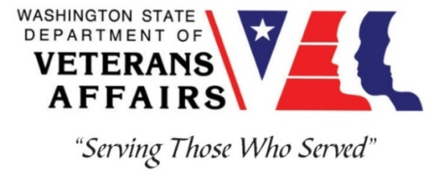
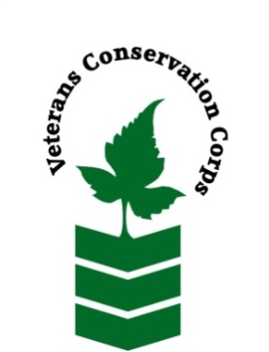

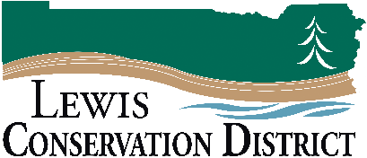

2057 SW Salsbury Ave.
Chehalis, WA 98532
(360) 996-4560
https://lewisconservation.wordpress.com
_____________________________________________________________________________________
Veterans Conservation Corps Crew Internship
with
Lewis Conservation District

Program Overview
The Lewis Conservation District is a non-regulatory local agency that works with landowners to help resolve their natural resource issues on their land. The mission of the Lewis Conservation District is to provide technical and financial assistance for the conservation, protection, and development of natural resources within Lewis County.
Location: Olympic School Room 36 – 2057 SW Salsbury Ave., Chehalis, WA
Compensation: $2,000 monthly stipend to assist with living expenses
Work Hours: Monday-Friday, 8:00am-4:30pm – Can be flexible
Duration: 1 year
Start Date: As soon as possible, position open until filled

Position Summary
We are seeking a Veterans Conservation Corps (VCC) member to assist with the monitoring and restoration of rare prairie habitat across the Chehalis watershed (Thurston, Lewis, and Grays Harbor counties) in southwest Washington. The VCC member will work with a small crew to enhance wildlife habitat, remove invasive weeds, monitor plant/pollinator/bird communities, promote responsible grazing practices, and educate landowners about conservation programs. This position requires a sound work ethic, strong interpersonal skills, and a positive attitude during long field days. We are committed to providing a meaningful experience for the VCC member and will support any veteran-specific needs that are appropriate to each Individual’s capabilities and condition during enrollment in program. The majority of the time will be spent in Lewis County while coordinating with other interns working in Thurston and Grays Harbor Counties for consistency.

Schedule and Compensation
Location: Chehalis, WA with travel to sites in rural Lewis County, and occasional travel to sites in Thurston and Grays Harbor Counties
Work Hours: Monday-Friday, 8:00am-4:30pm – Hours are flexible
This 12-month internship will begin as soon as possible (position open until filled), and includes a stipend of $2000/month for a full-time internship (~40 hours/week) to assist with living expenses.

Responsibilities
VCC member will serve with the Lewis Conservation District and partnering agencies to carry out the following duties:
- Restore native prairie habitat through mowing, prescribed burning, invasive species removal (e.g., herbicide application, brushcutting, etc.), and native plant seeding
- Collect field data on plant, pollinator, and bird communities
- Support project implementation through field season preparation, literature reviews, and data entry/management
- Communicate with landowners about conservation grazing techniques and conservation programs
- Work with Lewis Conservation District employees on other projects to gain experience and knowledge of other duties and opportunities conservation districts are involved with

Training Opportunities
All necessary training required to perform the essential functions/duties is provided on the job.
In addition to on-the-job training, this position may include the following formal trainings and certifications to aid in personal & professional development:
- NWCG Firefighter type II (Crew member) Certification
- Washington State Pesticide Applicators License
- Plant identification
- Habitat restoration and vegetation management techniques
- Chainsaw and brush cutting training
- Environmental conservation conferences/symposiums/workshops
- Growing your veteran-owned small business
- Grazing management
- Whole Farm Planning and Agricultural Entrepreneurship
- First Aid/CPR
- Posttraumatic Growth Training
- PTSD/TBI/Mental Health/ Suicide Awareness & Prevention
- WDVA Veteran Peer Corps Certification
- VCC Annual Training (every August)
- Other trainings/certifications as available and desired by intern
Requirements
- Must be a veteran of the United States Uniformed Services to be eligible for this position
- Must currently possess (or have the ability obtain) a valid driver’s license (or have reliable transportation to downtown Olympia office and field sites in rural areas)
- Fully vaccinated against COVID-19
- Must be able to perform strenuous field work on uneven terrain in adverse weather conditions
- Interest in learning about native plants, grazing techniques, and conservation programs
- Must be able to follow oral and written directions

Preferred Knowledge, Skills, and Abilities
- Plant identification skills, including common weeds (or eagerness to learn)
- Basic computer skills (e.g., use of web browsers and commonly used software such as Microsoft Office)
- Attention to detail
- Experience working on a crew to complete time-sensitive projects
- Experience implementing safety practices in the field with and without supervision
- Experience operating hand tools and power tools
- Comfortable working with chemicals such as herbicides and fertilizers
- Able to lift up to 50-lbs
- Able to operate motor vehicles and haul a trailer
- Comfortable speaking to landowners and other members of the public about projects
- Motivated and enthusiastic to work and learn

Apply
All applicants must pass a background check.
To apply for this internship, email a copy of your DD214 or service discharge certificate, a copy of your driver license, a resume, and a cover letter explaining your interest in this internship to:
Kim Pham
Veterans Conservation Corps Program Manager
kim@dva.wa.gov

Questions?
To learn more about the Veterans Conservation Corps, contact:
Kim Pham
Veterans Conservation Corps Program Manager
kim@dva.wa.gov

For more information about the Lewis Conservation District, contact:

Bob Amrine
Lewis Conservation District
bob.amrine@lewiscdwa.com
360-996-4560

