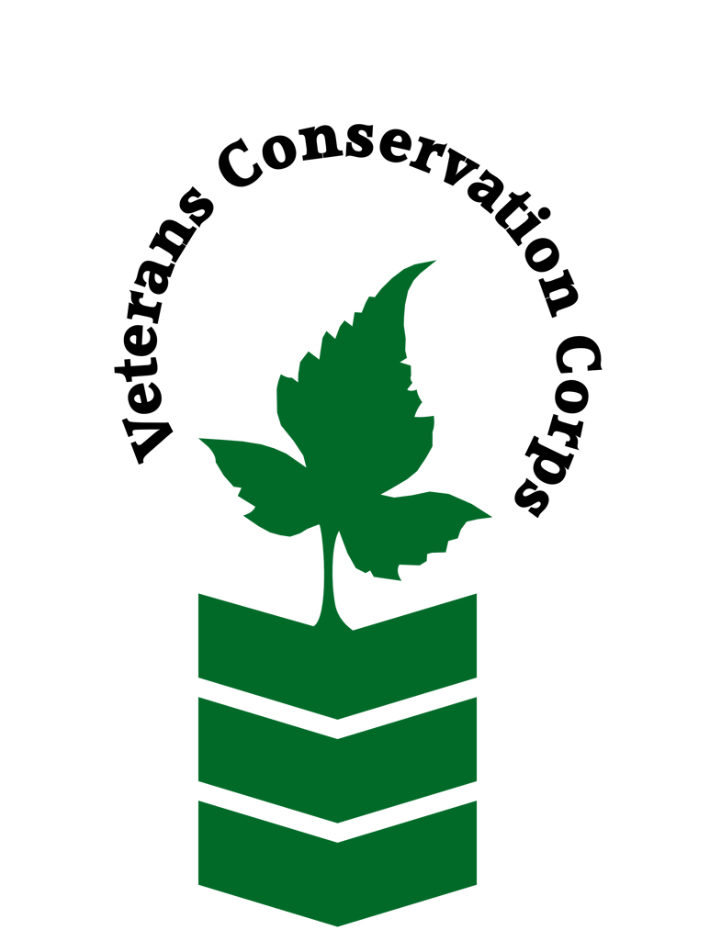
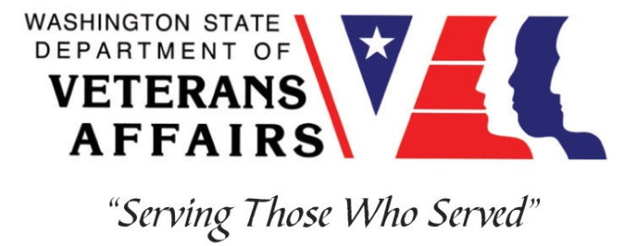
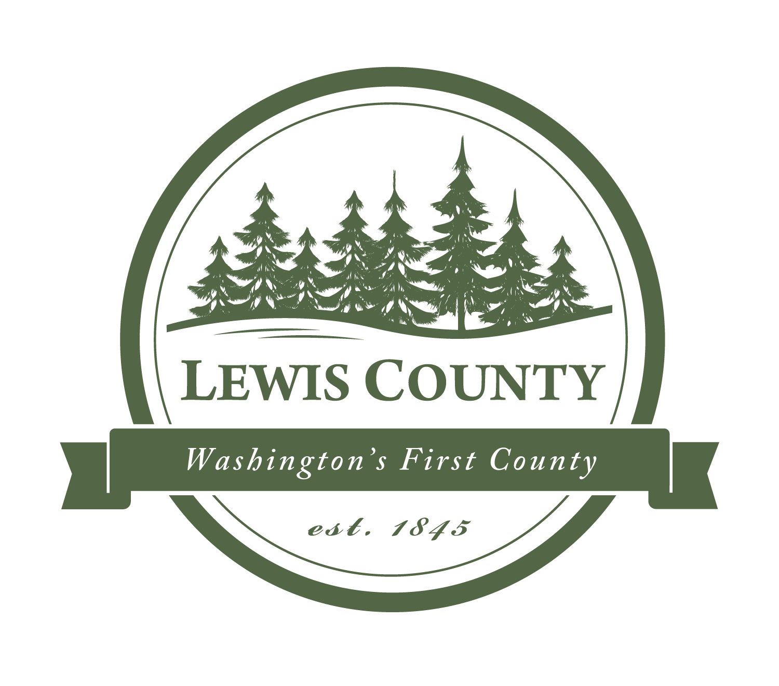

157 NW Chehalis Ave
Chehalis, WA 98532
Lewiscountywa.gov/departments/weed-control

Veterans Conservation Corps Internship Program
with
Lewis County Noxious Weed Control

Program Overview

Lewis County Noxious Weed Control is a county agency that aims to serve as responsible stewards of Lewis County land, by protecting ecological resources, wildlife habitat, and local agriculture, against the harms caused by noxious weeds. We endeavor to develop programs that reflect local priorities, meet the needs of county landowners and residents, and carry out the mandate of the Washington State noxious weed law, the RCW 17.10. The county Weed Control Program provides consultation on weed prevention strategies, educational programming, technical assistance, enforcement actions, and a variety of other resources to help control or eradicate noxious weeds in Lewis County, all free of charge at the point of service.

Position Summary

The candidate will:

During the off-season (November through March):

- Assist with multiple Education and Outreach events, examples including formal and informal presentations on identifying and managing local noxious weed species, or offering WA pesticide license continuing education (CE) credits for local residents, etc.
- Help prepare annual reports and process data or records from the previous field season
- Assist staff with planning and preparations for the upcoming field season
- Perform field surveys and limited manual or chemical noxious weed control activities, as appropriate and possible during winter months
- Support staff with various special projects, such as the creation of educational materials, etc., as time and interest allows

During the field season (April through October):

- Assist with landowner-requested site visits and site-specific recommendations for noxious weed management
- Help staff implement the Stewardship Incentive Program, a cost-share program for high-priority weed control on private lands in Lewis County, through landowner surveys and other follow-up
- Perform inspections for NAISMA weed-free forage certifications for local growers
- Execute county-wide noxious weed surveys and follow up with landowners on required-for-control noxious weed infestations
- Aid in manual and chemical weed control activities on public lands
- Assist with Education and Outreach events
- Support staff with the implementation and management of volunteer events and other projects
- Conduct GIS and data management activities for fieldwork

Schedule and Compensation

This 9-12 month internship begins in January 2023 and includes a VCC stipend of $2400/month for a full-time internship (~40 hours/week) or $1200/month for a part-time internship (~20 hours/week) to help cover living expenses. Position open until filled.
Schedule is flexible and can be 8 or 10 hour days, depending on staff activities and the time of year. The majority of field work (weed control activities, river surveying, and work in the Gifford Pinchot National forest) will require 10 hour days (0700 to 1700 M-Th). Other activities, including general surveying, site visits, education events, data entry, and mailing activities can be done on an 8-hour schedule (M-F 0800 to 1600). 10-hour days are reserved for field season (April to October) and a combination of the two schedules can often be accommodated.

There may be some weekend work opportunities, for staffing volunteer events, etc., but never weekend work requirements. Alternative hours and flexible scheduling to meet the intern’s needs will be discussed on a case-by-case basis.

Training

All necessary training required to perform the essential functions/duties is provided on the job.

In addition to on-the-job training, this position may include the following formal trainings and certifications to aid in personal & professional development:

- Herbicide mixing and application training
- Noxious weed knowledge and identification
- WA Pesticide License education, training and test (cost covered by LCNWC)
- Veterans Cultural Engagement Training
- Environmental conservation symposiums/workshops
- Posttraumatic Growth Training
- PTSD/TBI/Mental Health/ Suicide Awareness & Prevention
- Veteran Peer Support Training
- VCC Annual Training (every August)
- Other trainings/certifications as available and desired by intern

Requirements

- Must be a veteran of the United States Uniformed Services
- Must have dependable transportation to and from the Lewis County Noxious Weed office, located in downtown Chehalis, WA
- Must be able to work a 10 hour day at least 2 days a week April through September

Preferred Knowledge, Skills, and Abilities

This is considered an entry level position and no experience is required. Applicants with the following skills, knowledge, and abilities will be given preference:

- Currently possess or be able to obtain a valid driver’s license
- Experience implementing safety practices in the field with and without supervision
- Able to work outside in inclement weather conditions over uneven terrain
- Able to take direction and work as a member of a team
- Motivated and enthusiastic
- Organized and excellent attention to detail
- Comfortable speaking to landowners and other members of the public about projects
- Basic computer skills and data entry skills (Microsoft Word and Excel)
- GIS experience is a plus
- Plant based background or education is a plus

Apply

All applicants must pass a background check.

To apply, email a copy of your DD214 or service discharge certificate, a copy of your driver license, a resume, and a cover letter explaining your interest in this internship to:

Kim Pham
Veterans Conservation Corps Program Manager
kim@dva.wa.gov

Questions?

To learn more about the Veterans Conservation Corps, contact:

Kim Pham
Veterans Conservation Corps Program Manager
kim@dva.wa.gov

For more information about Lewis County Noxious Weed Control, contact:

Charles Edmonson
Noxious Weed Control Program Coordinator
360-740-1215
Charles.edmonson@Lewiscountywa.gov

