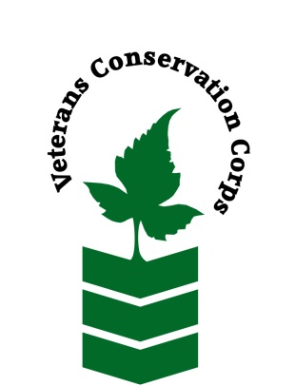
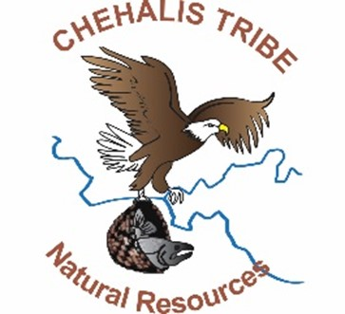

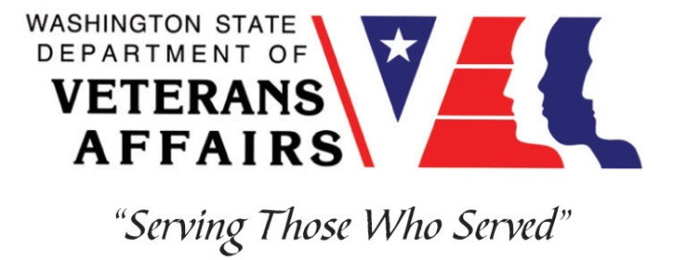

Veterans Conservation Corps
with the
Confederated Tribes
of the
Chehalis Reservation
Department of Natural Resources
Environmental Restoration Internship

Program Overview
The Chehalis Tribe’s Department of Natural Resources is located on the reservation near Oakville. The Department of Natural Resource’s mission statement is: Effectively manage the physical and cultural qualities of the air, water, earth, plants and wildlife, both on and off reservation, for the people of the Chehalis Tribes. Field work activities will include planting and providing maintenance to native trees and shrubs, controlling or removing invasive vegetation, fence barrier removal, and participating in other habitat improvement projects.

Position Summary

The candidate will:
Maintain Planting Sites:
- Intern will help maintain existing planting sites. This is done by safely utilizing tools such as brush-cutters and mowers and also includes manual watering.

Plant Native Trees and Shrubs:
- Intern will help plant both bare root plants and stakes in the riparian zone utilizing shovels, planting bars and sand-filled-hammers.

Invasive Weed Control:
- Intern will work to safely control invasive weeds by mechanical means (utilizing a brush cutter). Control will also include treating various weeds by applying herbicides utilizing a backpack sprayer.

Other Duties:
On an occasional basis the intern may have the opportunity to:
- Assist other District staff as needed, i.e. water data collection, fish trap data collection
- Operate watercraft used to access select work sites
- Collecting environmental field data
- Remove wildlife/livestock exclusion fencing
- Practice proper tool maintenance
- Other duties may be assigned

Physical Requirements
- Able to perform physically demanding manual labor outdoors on difficult and hazardous terrain in all types of weather.
- Capable of lifting 50 lbs., walking 3 miles daily over uneven terrain, and operating a brush cutter for 6-8 hours a day.
- Able to safely operate hand and power tools such as brush cutters water pumps, chainsaws, power auger, small tractors, planting bars, and pruners.
- Capable of bending, squatting, kneeling, lifting overhead, and other repetitive movements.

Schedule and Compensation
This is a 6-month internship that includes a VCC stipend of $2,400/month for a full-time internship (~40 hours/week) to help cover living expenses. A typical work week will be five 8-hour days from Monday-Friday from 8:00 am to 4:30 pm. Position open until filled.

Requirements
- Must be a veteran of the United States Uniformed Services to be eligible for this position
- Must have dependable transportation to and from the Chehalis Tribe DNR office on the Chehalis Tribe Reservation. [The address is 26 Niederman Rd, Oakville, WA, 98568.]
- Must be able to work Monday-Friday.

Preferred Knowledge, Skills, and Abilities

This is considered an entry level position and no experience is required. Applicants with the following skills, knowledge, and abilities will be given preference:
- Currently possess or be able to obtain a valid driver’s license
- Experience implementing safety practices in the field with and without supervision
- Able to work outside in inclement weather conditions
- Able to take direction and work as a member of a team
- Motivated and enthusiastic
- Excellent attention to detail
- Basic computer skills and data entry skills (Microsoft Word and Excel)

Training

All necessary training required to perform the essential functions/duties is provided on the job.

In addition to on-the-job training, this position may include the following formal trainings and certifications to aid in personal & professional development:
- Veterans Cultural Competency Training
- Posttraumatic Growth Training
- PTSD/TBI/Mental Health/ Suicide Awareness & Prevention
- WDVA Veteran Peer Corps Certification
- VCC Annual Training (every August)
- Environmental conservation conferences/symposiums/workshops
- Growing your veteran-owned small business
- Whole Farm Planning and Agricultural Entrepreneurship
- Other trainings/certifications as available and desired by intern

Additional Requirements
- Successfully pass pre-employment Drug Screen
- Be able to safely operate a motor vehicle and possess a valid Washington State Driver’s License.
- Successfully pass a Criminal Background Check. The following may disqualify an applicant from consideration or continued program participation:
  - Any felony conviction
  - Any domestic violence violations, convictions or restraints
  - Any violations, convictions or restraints for actions made against children or vulnerable adults
  - Any false or untrue statements or material omissions in the application and related paperwork or during the selection process

Apply

To apply, email a resume, a copy of your DD214 or service discharge certificate, a copy of your current driver’s license, and a cover letter explaining your interest in this internship to:

Kim Pham
Veterans Conservation Corps Program Manager
kim@dva.wa.gov

Questions?

To learn more about the Veterans Conservation Corps, contact:

Kim Pham
Veterans Conservation Corps Program Manager
kim@dva.wa.gov

For more information about Chehalis Tribe Department of Natural Resources, contact:

Ben Amidon
Restoration Coordinator
bamidon@chehlistribe.org
(360) 951-5447
https://www.chehalistribe.org/departments/department-of-natural-resources/

