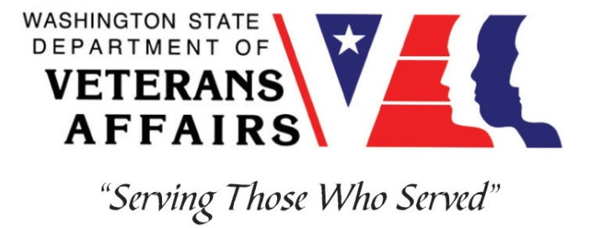
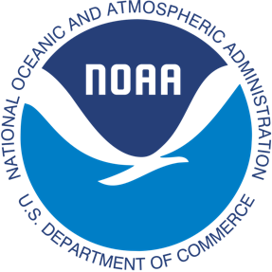
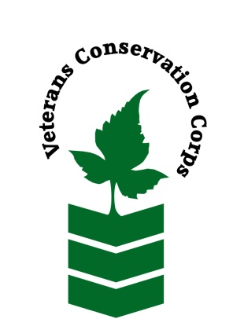
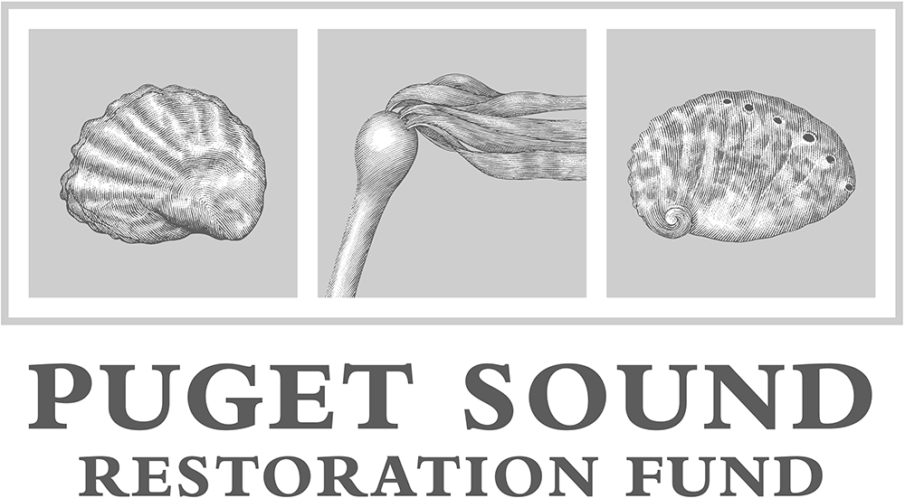

Kenneth K. Chew Center for Shellfish Research and Restoration at
Northwest Fisheries Science Center’s Manchester Research Station
7305 Beach Dr E, Manchester, WA 98353
(206) 780-6947 or (206) 795-6378
https://www.nwfsc.noaa.gov/ and https://restorationfund.org/programs/hatchery/
NOAA WDVA Veterans Conservation Corps Fisheries Internship Program
with the
Puget Sound Restoration Fund

***This position requires the applicant to be a veteran of the United States Uniformed Services ***

Period of Performance: April-August 2023

Program Description

The NOAA WDVA Veterans Conservation Corps Fisheries Internship Program is a Washington-based internship focused on marine science and stewardship of coastal resources. Since 2016, NOAA has been funding these internships and partnering with the WDVA Veterans Conservation Corps to deliver high level science-based experiences at NOAA Research Centers and NOAA partner organizations throughout Washington. This internship adds Puget Sound Restoration Fund (PSRF) to this NOAA and WDVA Veterans Conservation Corps partnership. The internship will be supervised by PSRF and located at the Kenneth K. Chew Center for Shellfish Research and Restoration (Chew Center) that PSRF operates at NOAA’s Manchester Research Station on the Kitsap Peninsula and at field locations throughout Puget Sound. The position will be supported and coordinated by the VCC and NOAA.

This position is with PSRF, a non-profit organization that works to restore abundant marine resources and our connections to them through a diverse portfolio of in-the-water projects throughout Puget Sound. The main focus of PSRF restoration is living marine habitat and species, using structure forming species (Olympia oysters, bull kelp) and habitat enhancing species (pinto abalone). Another focus for PSRF is maintaining and recovering clean water in shellfish growing areas and developing mitigation strategies for ocean acidification. PSRF is dedicated to measurably improving conditions in Puget Sound through: improved water quality, increased abundance of native species, additional acres of restored habitat, enhanced ecological benefits, and re-forged connections with healthy marine resources.

Position Description

The VCC intern will work both at the Chew Center and in the field, on research and restoration projects. As part of the PSRF team, the intern will have the opportunity to assist with many projects, gain a variety of experiences across programs, and have support from PSRF staff to ensure tasks are successfully accomplished.

At the Chew Center, the intern will assist across PSRF’s programs, including hatchery production of restoration-grade pinto abalone, Olympia oysters, and possibly kelp, microalgae culture, animal husbandry, data collection and management, and facilities maintenance. Husbandry work includes maintaining broodstock, larval, post-set and juvenile culture systems daily, keeping accurate records of growth, survival, and culture conditions, and assisting with induced spawns. Microalgae culture includes assisting with monitoring cultures, sterile transfers and media preparation, which includes handling chemicals. Facilities and operational system support entails regular cleaning/repair/replacement of water treatment system components (e.g., filters, pumps, heaters, heat exchangers).

In the field, the intern will provide capacity across a variety of PSRF projects, working with Olympia oysters, bull kelp, cockles, seaweed and on PSRF’s Community Shellfish Farm. Responsibilities include assistance with biological surveys and studies, including sample collection, preservation, and processing, data collection and archiving; logistics support, materials acquisition and minor fabrication; and sorting oysters and maintaining gear at the shellfish farm. Field work occurs in various locations across Puget Sound, and involves hiking on rocky beaches and mudflats, frequent heavy lifting, and working from small boats.
Additionally, there are also anticipated to be opportunities to network and communicate with NOAA research staff and communicate the results and experiences of this internship.

Schedule and Compensation

This internship includes a stipend of $2400/month from the VCC and a supplemental stipend of $500/month from PSRF for a full-time internship (approximately 40 hours/week) to help cover living expenses. Start date is flexible, and position will remain open until filled.

Interns are expected to serve up to 40 hours over four or five days each week. As field activities are scheduled in accordance with the tides, the intern is expected to periodically work odd hours, longer than 8-hr days and during inclement weather. Alternative hours and flexible scheduling to meet the intern’s needs will be discussed on a case-by-case basis.

Required Skills, Knowledge, and Abilities

- This position requires the applicant to be a veteran of the United States Uniformed Services.

Preferred Qualities

Applicants with the following skills, knowledge, and abilities will be given preference.
- Experience with marine or aquatic organism care or culture, microscopy, general laboratory equipment and procedures
- Ability to work independently and as a member of a team
- Strong self-initiative, and good attention to detail
- Follows appropriate safety practices in the lab and the field
- Motivated and enthusiastic, with an interest in marine ecosystems, environmental restoration and conservation

Physical Requirements:

- Ability to work outdoors in all weather conditions

Training

All necessary training required to perform the essential functions/duties is provided on the job.

In addition to on-the-job training, this position may include the following formal trainings and certifications to aid in professional development and job training:

- Posttraumatic Growth Training
- PTSD/TBI/Mental Health/ Suicide Awareness & Prevention
- Veteran Peer Support Training
- Environmental conservation conferences/symposiums/workshops
- Other trainings/certifications as available and desired by intern

Apply

All applicants must pass a background check.

To apply, email a resume, a copy of your DD214 or service discharge certificate, a copy of your current driver’s license, and a cover letter explaining your interest in this internship to:

Kim Pham
Veterans Conservation Corps Program Manager
kim@dva.wa.gov

Questions?

To learn more about the NOAA WDVA Veterans Conservation Corps Internship Program and this particular internship, contact:

Kim Pham
Veterans Conservation Corps Program Manager
kim@dva.wa.gov

John Floberg
NOAA
Marine Habitat Resource Specialist
John.r.floberg@noaa.gov

Jodie Toft Ryan Crim
PSRF PSRF
jodie@restorationfund.org ryan@restorationfund.org
(206) 795-6378 (206) 406-8827

