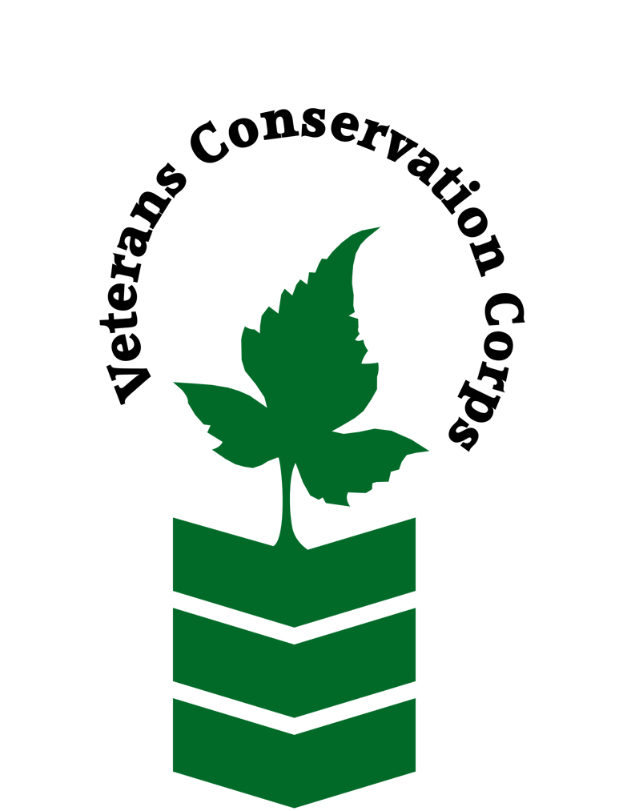
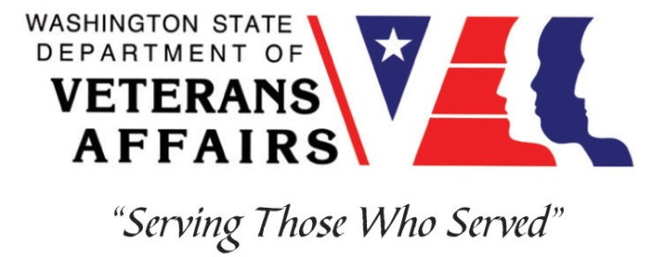
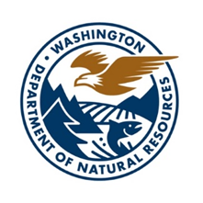
1111 Washington St SE, Olympia, WA 98504
dnr.wa.gov/programs-and-services/aquatics/habitat-conservation/invasive-species-control

Veterans Conservation Corps
with
Washington Department of Natural Resources
Aquatic Invasive Species Management Internship

***This position requires the applicant to be a veteran of the U.S. Uniformed Services***

Program Overview
DNR Aquatic Resources Division’s Invasive Species Program (AIS) works with a broad array of public, private and tribal partners throughout the state to control—or eradicate where possible—aquatic invasive plants and animals through a variety of integrated pest management (IPM) techniques to protect and enhance Washington’s valuable aquatic resources on over 2.6 million acres of state-owned aquatic lands (SOAL).

Position Summary
DNR AIS cooperates with its partners to collect data in the field using a variety of technologies, along with analysis and mapping to evaluate progress. Team member responsibilities include site surveys and inspections, coordination of control activities with project partners, and report writing. Work is directed by a lead regional AIS Coordinator and is largely conducted independently or with partners in remote conditions.

A big part of successful habitat restoration and improvement is identifying and controlling invasive plants and animals that get in the way of a healthy, functional ecosystem. Integrated pest management principles guide invasive species control activities, and include manual, mechanical, biological, and chemical techniques. Hand tools may include brush cutters, shovels, machetes, chainsaws, and backpack sprayers. Sites are accessed using a broad array of equipment including all-terrain vehicles, tractors, kayaks, airboats, and MarshMasters, as well as by foot. Approved training is available through DNR AIS for operating various types of equipment.

Safety for the environment, the public, and those performing control tasks is of paramount importance. Daily tasks may expose team members to quickly changing weather and terrain, pollen, insects, fast-moving waters, and other environmental conditions. Operating machinery and using herbicides are other potential risks while performing weed control work. Team members are encouraged to acquire, a WSDA Pesticide Applicator’s License and Aquatics endorsement in order to work with herbicides in aquatic settings safely and effectively—and legally.

Duties and Responsibilities
- Assist with survey and control of noxious weeds and other invasive species while ensuring compliance with Washington State regulations.
- Prepare reports of infestations and treatments identified through field inspections.
- Apply herbicides or other control measures as directed by DNR AIS Regional Coordinator.
- Operate and maintain equipment such as GPS transmitters, watercraft, backpack sprayers, vehicles, and a variety of hand and power tools.
- Conduct survey and control work for European Green Crab with a regional focus for activities occurring in Grays Harbor, Willapa Bay and the outer coast.

Schedule and Compensation
This 3-month internship begins in April 2023 and includes a VCC stipend of $2400/month for a full-time internship (~40 hours/week) to help cover living expenses. Monday through Friday from 8am to 5pm, with occasional extended field days. Alternative hours and flexible scheduling to meet the intern’s needs will be discussed on a case-by-case basis. Position open until filled.

Requirements
- This position requires the applicant to be a veteran of the United States Uniformed Services.
- Current valid Washington State driver's license.

Preferred Qualities
Minimum qualifications are not established for this position; however, applicants with the following skills, knowledge, and abilities will be given preference:
- Good communication and writing skills.
- Experience in plant identification (native, non-native, and ornamental).
- Washington State Dept. of Agriculture Pesticide Applicator’s License and Aquatic endorsement.
- Washington State Boater Education Card or approved USCG Boating Class or equivalent armed services documentation.
- Experience operating watercraft (small boats with outboard engines, kayaks, etc.)
- Experience operating off-road and amphibious vehicles (ATV, UTV, ORV, etc.).
- Experience towing trailers.
- Working knowledge of ArcGIS.
- Familiarity with Microsoft office programs (Word, Excel, PowerPoint, etc.).

Physical Requirements
- Comfortable working in remote settings, often independently.
- Capable of carrying 40 pounds (fully-loaded backpack sprayer).
- Able to stand and/or walk for 8-10 hour shifts in challenging terrain and weather.
- Able to participate in regular travel and multiple-day work trips across the State.

Training
All necessary training required to perform the essential functions/duties is provided on the job.

In addition to on-the-job training, this position may include the following formal trainings and resources to aid in personal & professional development:
- WSDA Pesticide Applicator’s License and Aquatics endorsement
- Watercraft operation training (small boats with outboard engines, kayaks, etc.)
- Off-road and amphibious vehicle operations training (ATV, UTV, ORV, etc.)
- Basic first aid, CPR, and safety training
- Native and invasive species identification training
- Veterans Cultural Engagement Training
- Posttraumatic Growth Training
- PTSD/TBI/Mental Health/ Suicide Awareness & Prevention
- WDVA Veteran Peer Corps Certification
- Environmental conservation conferences/symposiums/workshops
- Other trainings/certifications as available and desired by intern

Apply
To apply, email a resume, a copy of your DD214 or service discharge certificate, a copy of your current driver’s license, and a cover letter explaining your interest in this internship to:

Kim Pham
Veterans Conservation Corps Program Manager
kim@dva.wa.gov

Questions?
To learn more about the Veterans Conservation Corps, contact:

Kim Pham
Veterans Conservation Corps Program Manager
kim@dva.wa.gov

For more information about the DNR Aquatic Invasive Species Program, contact:

Caleb Dobey
Aquatic Invasive Species Coordinator
caleb.dobey@dnr.wa.gov
360-890-6975

Todd Palzer
Aquatic Invasive Species Program Manger
todd.palzer@dnr.wa.gov
360-280-9153

dnr.wa.gov/programs-and-services/aquatics/habitat-conservation/invasive-species-control

