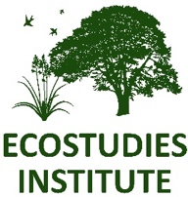
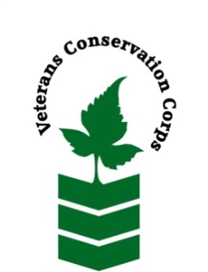
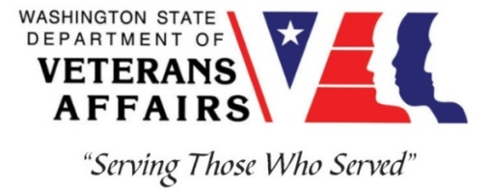

900 Jefferson St. SE
P.O. Box 1614, Olympia, WA 98501
www.ecoinst.org
_____________________________________________________________________________________
Veterans Conservation Corps Crew Internship
with
Ecostudies Institute

Program Overview
Ecostudies Institute is a 501(c)(3) non-profit conservation organization dedicated to the conservation of native species and their ecosystems. Our natural environment faces complex and dynamic threats which we address with effective partnerships, conservation research and strategic, science-based management to create exceptional and lasting improvements for the species and habitats we support. Because ecological conservation is vitally linked to community, we work to promote environmental justice by removing barriers to engagement and improving access to environmental education and career opportunities for underserved populations. In particular, we recognize the inextricable connection between Indigenous peoples and their ancestral lands and seek to actively support that relationship.

Location: Olympia, WA with travel to sites in rural Thurston, Lewis, and Grays Harbor counties
Compensation: $2,000 monthly stipend to assist with living expenses
Work Hours: Monday-Friday, 8:00am-4:30pm
Duration: 1 year
Start Date: As soon as possible, position open until filled

Position Summary
We are seeking a Veterans Conservation Corps (VCC) member to assist with the monitoring and restoration of rare prairie habitat across the Chehalis watershed (Thurston, Lewis, and Grays Harbor counties) in southwest Washington. The VCC member will work with a small crew to enhance wildlife habitat, remove invasive weeds, monitor plant/pollinator/bird communities, promote responsible grazing practices, and educate landowners about conservation programs. This position requires a sound work ethic, strong interpersonal skills, and a positive attitude during long field days. We are committed to providing a meaningful experience for the VCC member and will support any veteran-specific needs that are appropriate to each Individual’s capabilities and condition during enrollment in program.

Schedule and Compensation
Location: Olympia, WA with travel to sites in rural Thurston, Lewis, and Grays Harbor counties
Work Hours: Monday-Friday, 8:00am-4:30pm
This 12-month internship will begin as soon as possible (position open until filled), and includes a stipend of $2000/month for a full-time internship (~40 hours/week) to assist with living expenses.

Responsibilities
VCC member will serve with Ecostudies Institute and partnering agencies to carry out the following duties:
- Restore native prairie habitat through mowing, prescribed burning, invasive species removal (e.g., herbicide application, brushcutting, etc.), and native plant seeding
- Collect field data on plant, pollinator, and bird communities
- Support project implementation through field season preparation, literature reviews, and data entry/management
- Communicate with landowners about conservation grazing techniques and conservation programs

Training Opportunities
All necessary training required to perform the essential functions/duties is provided on the job.
In addition to on-the-job training, this position may include the following formal trainings and certifications to aid in personal & professional development:
- NWCG Firefighter type II (Crew member) Certification
- Washington State Pesticide Applicators License
- Plant identification
- Habitat restoration and vegetation management techniques
- Chainsaw and brush cutting training
- Environmental conservation conferences/symposiums/workshops
- Growing your veteran-owned small business
- Grazing management
- Whole Farm Planning and Agricultural Entrepreneurship
- Posttraumatic Growth Training
- PTSD/TBI/Mental Health/ Suicide Awareness & Prevention
- WDVA Veteran Peer Corps Certification
- VCC Annual Training (every August)
- Other trainings/certifications as available and desired by intern

Requirements
- Must be a veteran of the United States Uniformed Services to be eligible for this position
- Must currently possess (or have the ability obtain) a valid driver’s license (or have reliable transportation to downtown Olympia office and field sites in rural areas)
- Fully vaccinated against COVID-19
- Must be able to perform strenuous field work on uneven terrain in adverse weather conditions
- Interest in learning about native plants, grazing techniques, and conservation programs
- Must be able to follow oral and written directions

Preferred Knowledge, Skills, and Abilities
- Plant identification skills, including common weeds (or eagerness to learn)
- Basic computer skills (e.g., use of web browsers and commonly used software such as Microsoft Office)
- Attention to detail
- Experience working on a crew to complete time-sensitive projects
- Experience implementing safety practices in the field with and without supervision
- Experience operating hand tools and power tools
- Comfortable working with chemicals such as herbicides and fertilizers
- Able to lift up to 50-lbs
- Able to operate motor vehicles and haul a trailer
- Comfortable speaking to landowners and other members of the public about projects
- Motivated and enthusiastic to work and learn

Apply
All applicants must pass a background check.
To apply for this internship, email a copy of your DD214 or service discharge certificate, a copy of your driver license, a resume, and a cover letter explaining your interest in this internship to:
Kim Pham
Veterans Conservation Corps Program Manager
kim@dva.wa.gov

Questions?
To learn more about the Veterans Conservation Corps, contact:
Kim Pham
Veterans Conservation Corps Program Manager
kim@dva.wa.gov

For more information about Ecostudies Institute, contact:

Melissa Habenicht
Ecostudies Institute
mhabenicht@ecoinst.org
423-237-2820

Ecostudies Institute is an Equal Opportunity employer. Personnel are chosen on the basis of ability without regard to race, color, religion, sex, national origin, disability, marital status or sexual orientation, in accordance with federal and state law.

