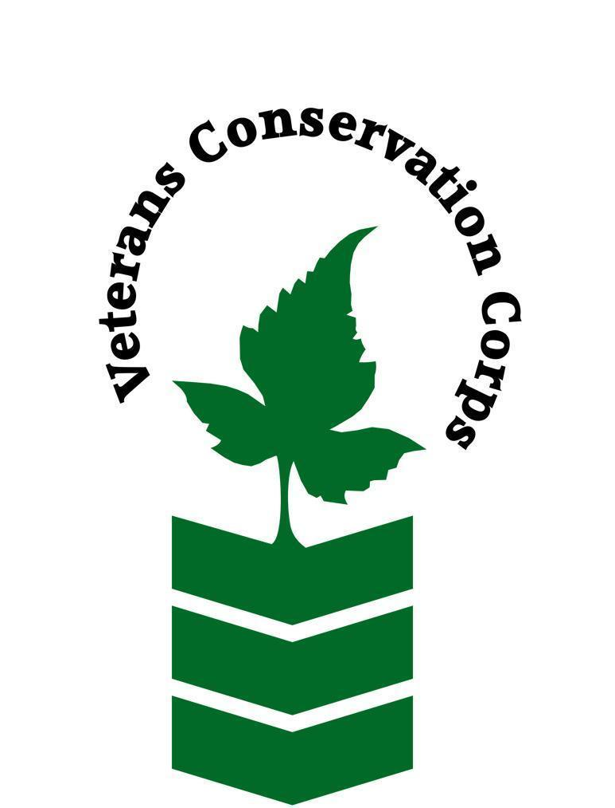
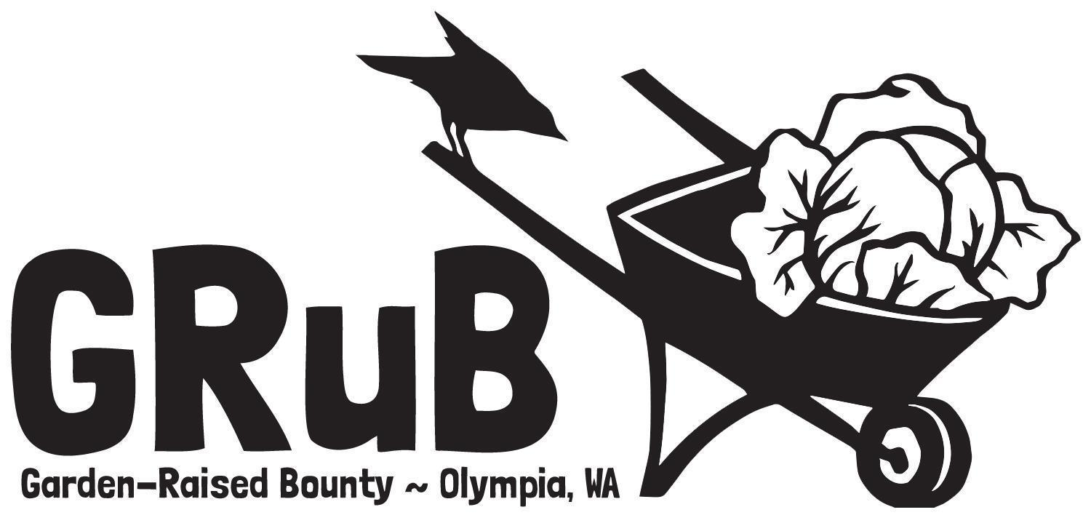

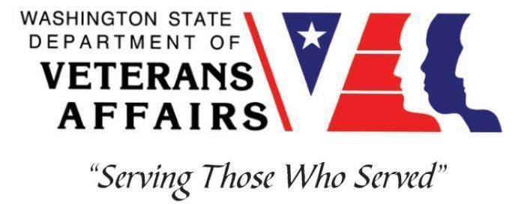

2016 Elliott Ave NW, Olympia, WA 98502
goodgrub.org

Veterans Conservation Corps
with
Garden-Raised Bounty
GRuB Garden Project Internship

***This position requires the applicant to be a United States military veteran***

Program Overview

Garden-Raised Bounty (GRuB) is a 501c3 organization based in Olympia, WA. Our mission is to grow healthy food, people, and community. With roots in the land, we create opportunities for people to learn, lead, and thrive. We envision an equitable world where we are all nourished by healthy relationships, resilient community, and good food.

Our work lives at the intersection of food, education, and health systems. Each year, we directly engage approximately 1500 Thurston County residents of all ages in relationships-based programming centered on growing and preparing good food. We primarily work with young people, families with low incomes, students, seniors experiencing hunger, tribal communities, veterans, active-duty service members, and their families. Visit goodgrub.org for more information.

We strive to cultivate an organizational culture of camaraderie, support, and appreciation among staff and a family-friendly work environment. We also eat a lot of good food together!

Position Summary

Lead Builder Intern: The Lead Builder Intern will gain hands-on experience in community building & garden building by supporting the GRuB Garden Project (GGP) team in coordinating and constructing backyard gardens with low-income families in our community. The Lead Builder Intern will assist in leading teams of volunteers and other interns to construct over 30 gardens throughout the Spring Quarter. This position will also help assist the GGP coordinator to facilitate gardener relationships, schedule builds, and help facilitate workshops with the GRuB Garden Project manager. The position may also provide regular office & organizational support as needed. You will work closely with the GRuB Garden Project coordinator and other GRuB staff, volunteers and interns.

Responsibilities may include:

GRuB Garden Project:
- Support the GRuB Garden Coordinator as needed.
- Develop gardener orientation materials & resources.
- Coordinate garden builds with gardeners & maintain communication with gardeners as needed.
- Drive the GGP truck and lead teams of volunteers and interns on garden builds.
- Safe operation of a full-size truck with dump-bed and various garden construction tools, i.e. drills, wheelbarrows, shovels, hammers, saws.
- Represent GRuB to veterans, volunteers, and general community members.
- Offer a welcoming, knowledgeable and friendly presence to veterans and volunteers.
Other Duties:
- Participate in community outreach events and funding events as needed.
- Other program and administrative duties assigned by the supervisor.
- Ongoing photo and written documentation of program activities.
- Participate in weekly GGP team meetings.

Schedule and Compensation

This 6-month internship, with possibility of extension, includes a VCC stipend of $2400/month for a full-time internship (~40 hours/week) or $1200/month for a part-time internship (~20 hours/week) to help cover living expenses. Position will remain open until filled.

Flexible schedule. The Intern will work closely with the GGP Coordinator and Community Food Solutions Manager to determine a schedule that meets their needs. A typical work week consists of Monday – Friday, 9 am – 5 pm. There may be occasional early morning, evening and/or weekend work hours that will be pre-scheduled to fit within 20 hours/week (part-time) or 40 hours/week (full-time). Alternative hours and flexible scheduling to meet the intern’s needs will be discussed on a case-by-case basis.

Requirements
- This position requires the applicant to be a veteran of the United States Uniformed Services
- Valid Driver’s license.
- Personal means of transportation to travel to and from GRuB and/or garden build sites
- Physically able to conduct physically demanding work in a variety of weather conditions.
- Ability to lift 20-40 pounds.
- Ability to safely operate a full-size pick-up truck

Preferred Knowledge, Skills, and Abilities
- Ability to work independently in the field while demonstrating a strong work ethic and safety common sense.
- Ability to work as part of a team of staff and/or community volunteers in the field.
- Enthusiastic about working with people from diverse backgrounds.
- Curious, open-minded, respectful and committed to developing multicultural communication skills.
- Ability to act as a leader and uphold high ethical standards.
- Timeliness and reliability
- Excellent communication skills.
- Excellent attention to detail.
- Willingness to learn new skills.
- Experience with MS Office programs
- First-aid training

Training

All necessary training required to perform the essential functions/duties is provided on the job.

In addition to on-the-job training, this position may include the following formal training and certifications to aid in personal and professional development:

- Whole Farm Planning Course
- Agricultural Entrepreneurship & Business Planning Workshop
- Posttraumatic Growth Training
- PTSD/TBI/Mental Health/ Suicide Awareness & Prevention
- Veteran Peer Support Training
- Other trainings/certifications as available and desired by intern

Apply

All applicants must pass a background check.

To apply, email a copy of your DD214 or service discharge certificate, a copy of your driver license, a resume, and a cover letter explaining your interest in this internship to:

Kim Pham
Veterans Conservation Corps Program Manager
kim@dva.wa.gov

Questions?

To learn more about the Veterans Conservation Corps, contact:

Kim Pham
Veterans Conservation Corps Program Manager
kim@dva.wa.gov

For more information about GRuB, contact:

Jennah Kemp
GRuB Veterans Program Manager
jennah@goodgrub.org

